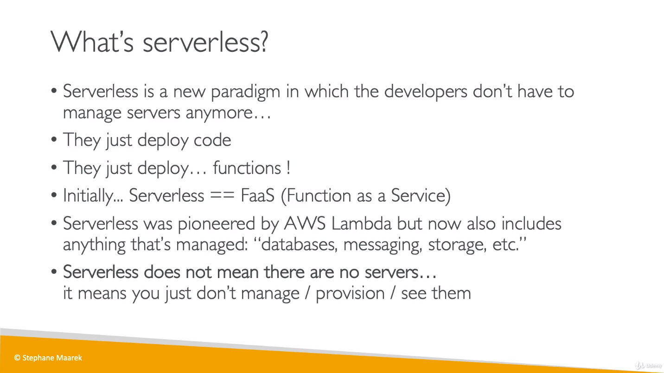

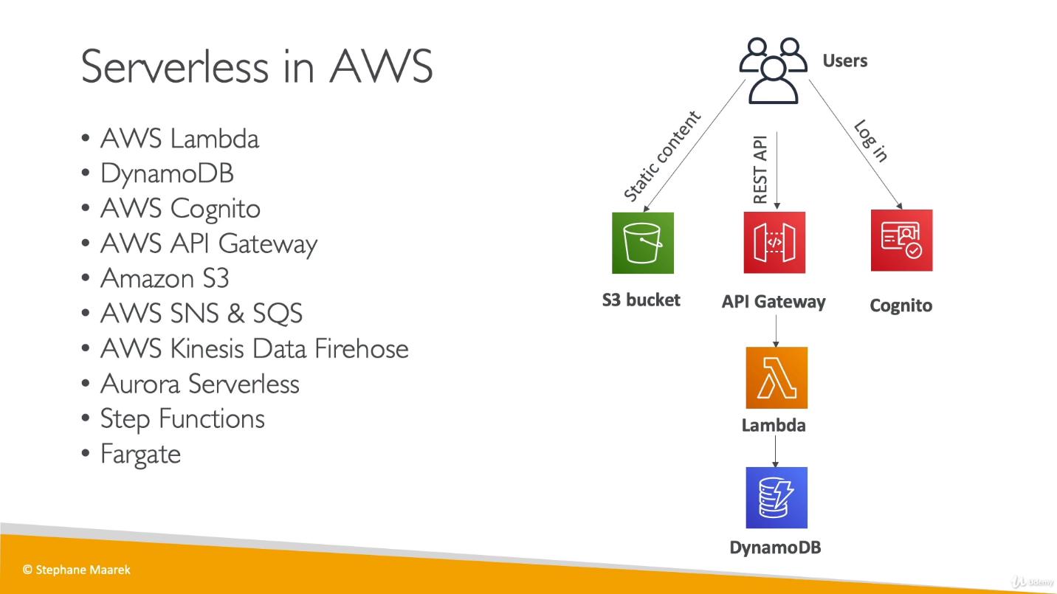

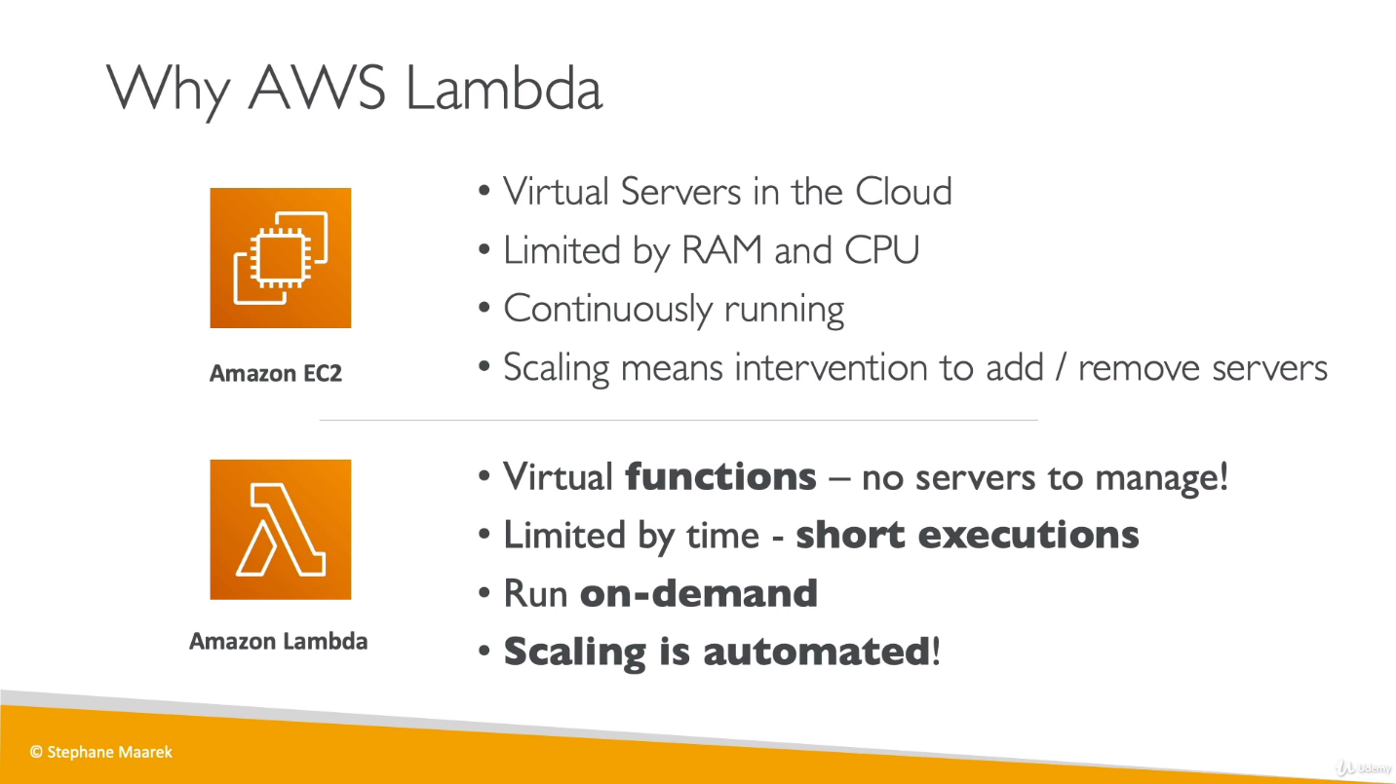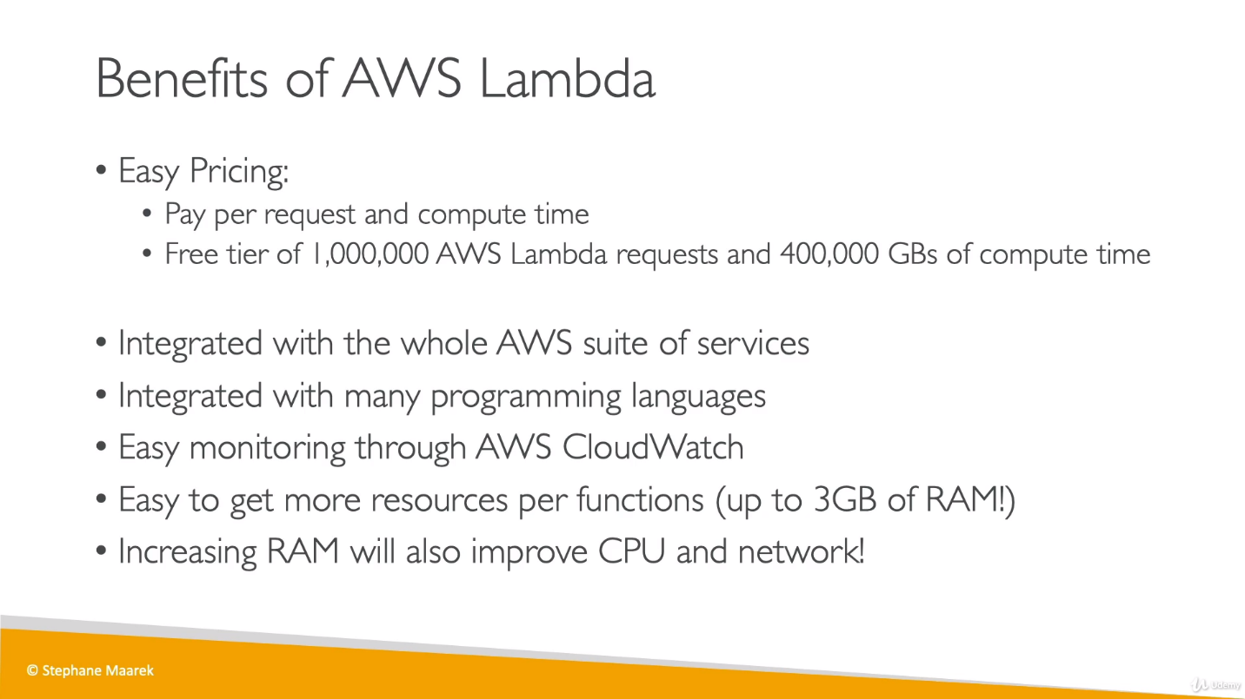

Lambda doesn’t support Docker.

We wrote lambda functions in below mentioned languages and it will triggered whenever it is required based on it’s integration with other services.

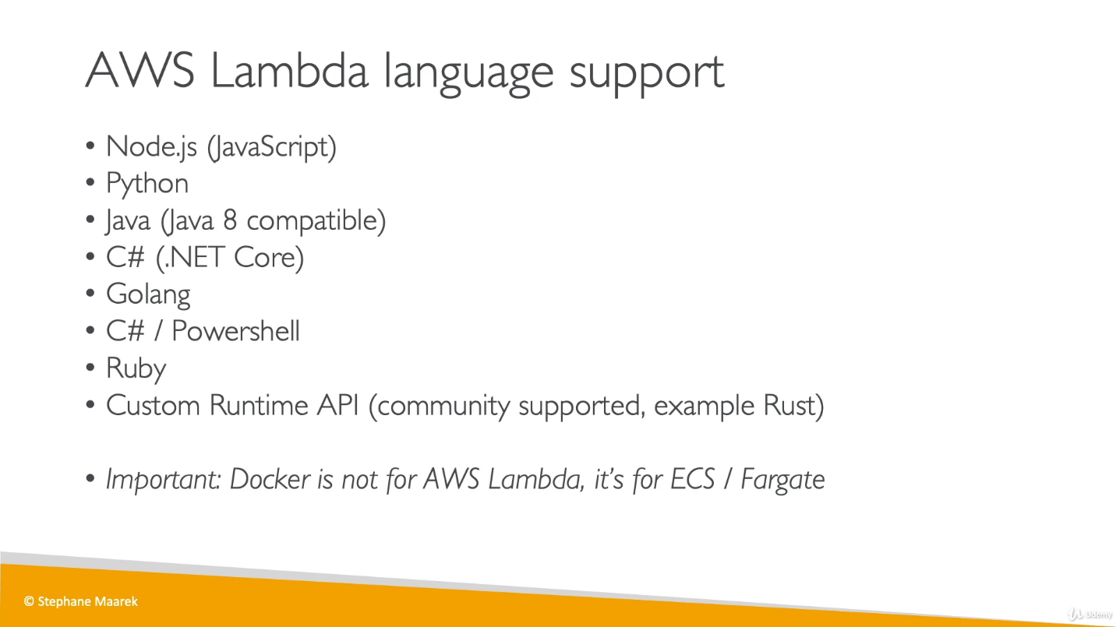

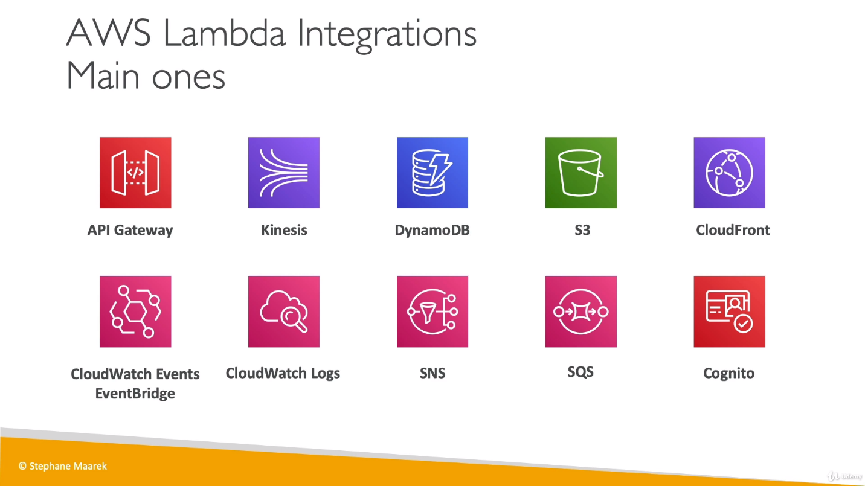

We have Amazon services which have some integration with lambda which means their actual work is getting extended using lambda function which is making them more capable.

* **API Gateway**: To create REST API and they will invoke lambda function.
* **Kinesis**: To do data transformation on the fly [real time/ something that is being changed while the process that the change affects is ongoing].
* **DynamoDB**: To create some triggers so whenever something happens in our DB, a lambda function will be triggered.
* **S3**: A lambda function will be triggered whenever required like created a file in S3.
* **CloudFront**: Lambda@Edge, Lambda@Edge is a feature of Amazon CloudFront that lets you run code closer to users of your application, which improves performance and reduces latency.
* **CloudWatch Event or EventBridge**: Whenever something happens in our infrastructure on AWS and want to able to react to things. Ex, we have a code pipeline stage changes and we want to do some automation based on it, we can use lambda function.
* **CloudWatch logs**: Whenever lambda function run, it’s logs will be going and saving into CloudWatch.

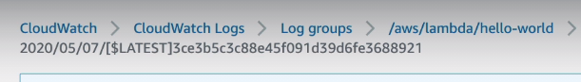

Each lambda function invocation will create a new log stream so if anything goes wrong we can check these logs and can debug function.

* **SNS**: To react to the notifications and SNS topics.
* **SQS**: To process messages from SQS queues.
* **Cognito**: To react to whenever use logs into database.

**Ex1: Steps involved in Serverless Thumbnail creation:**

**Thumbnails:** Thumbnails are reduced-size versions of pictures or videos.

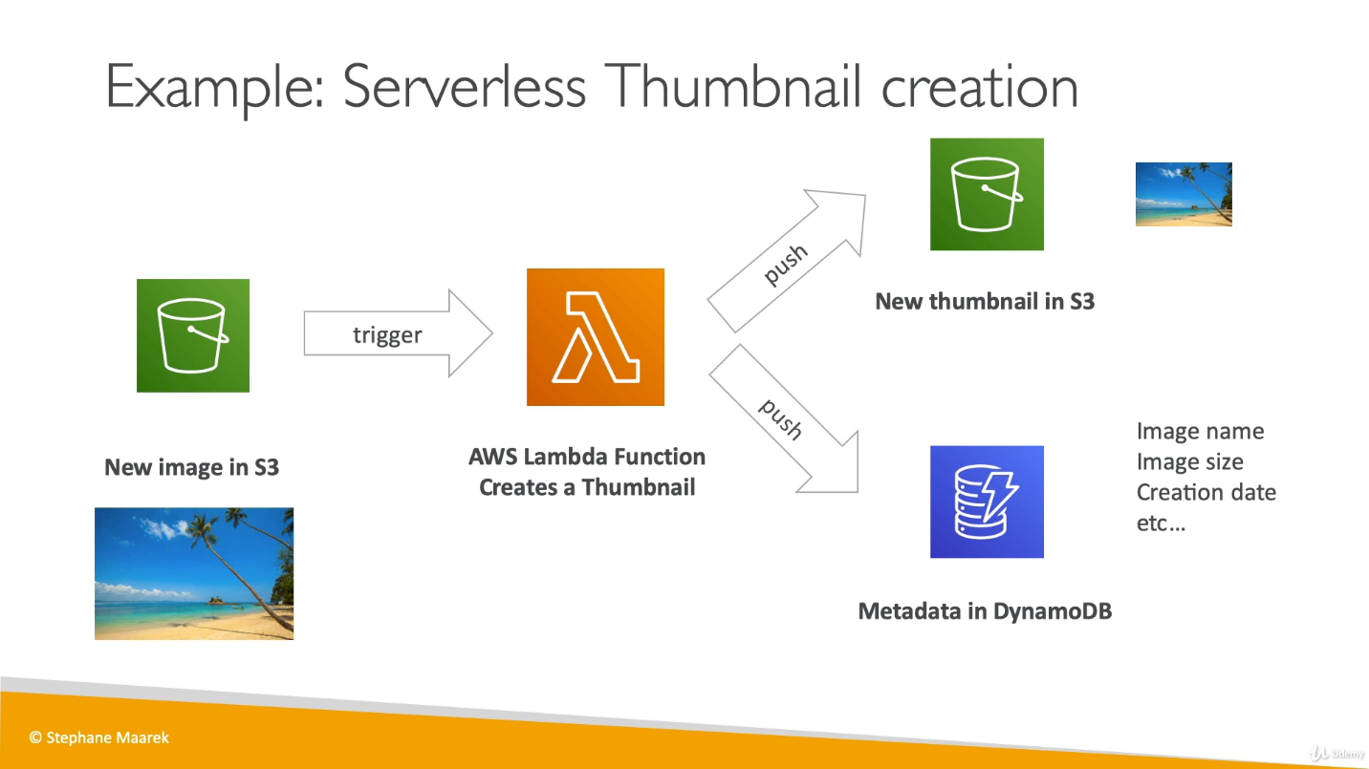

In above example, S3 event is getting triggered whenever any image is getting pushed into S3 bucket, this event will invoke lambda function and now lambda function will create a thumbnail of S3’s new image and send it back to S3, meanwhile it is also saving metadata information in DynamoDB.

Ex2: Serverless CRON job (A schedule job which run on an interval) So we can use this job to invoke lambda function on any trigger.

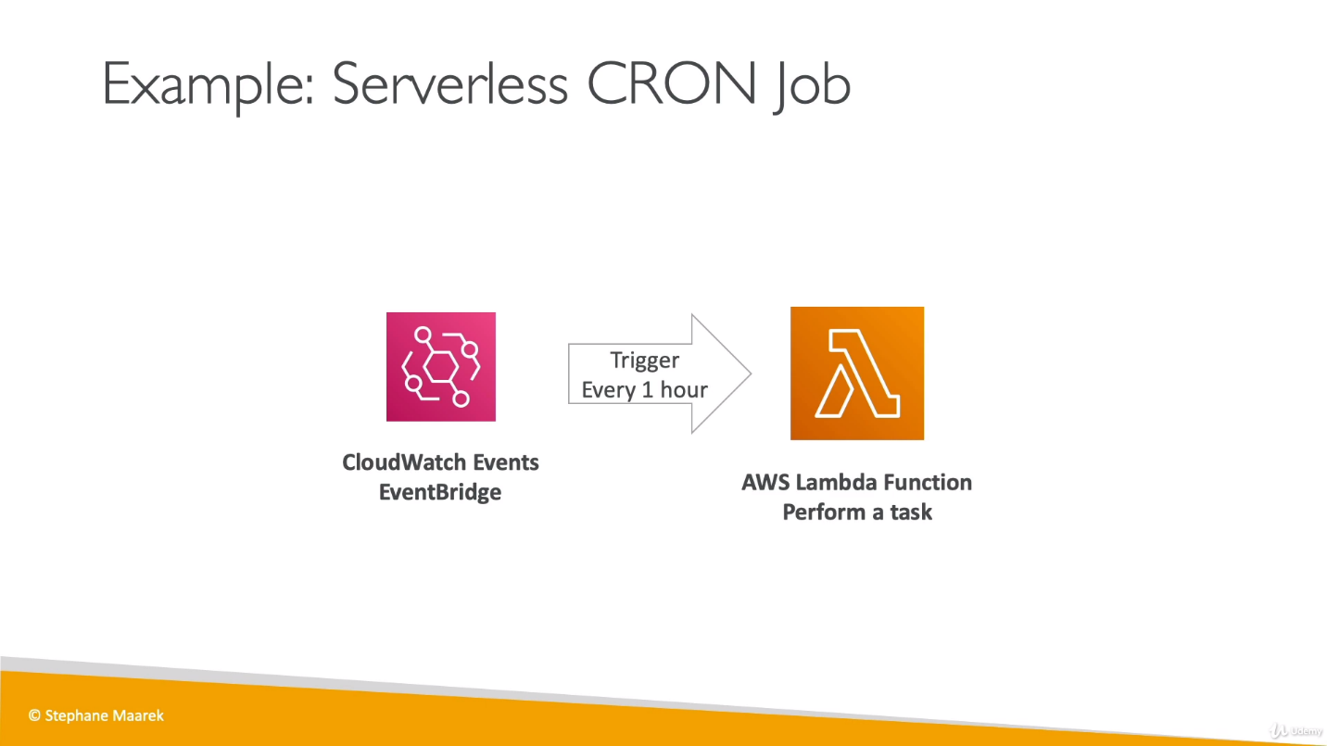

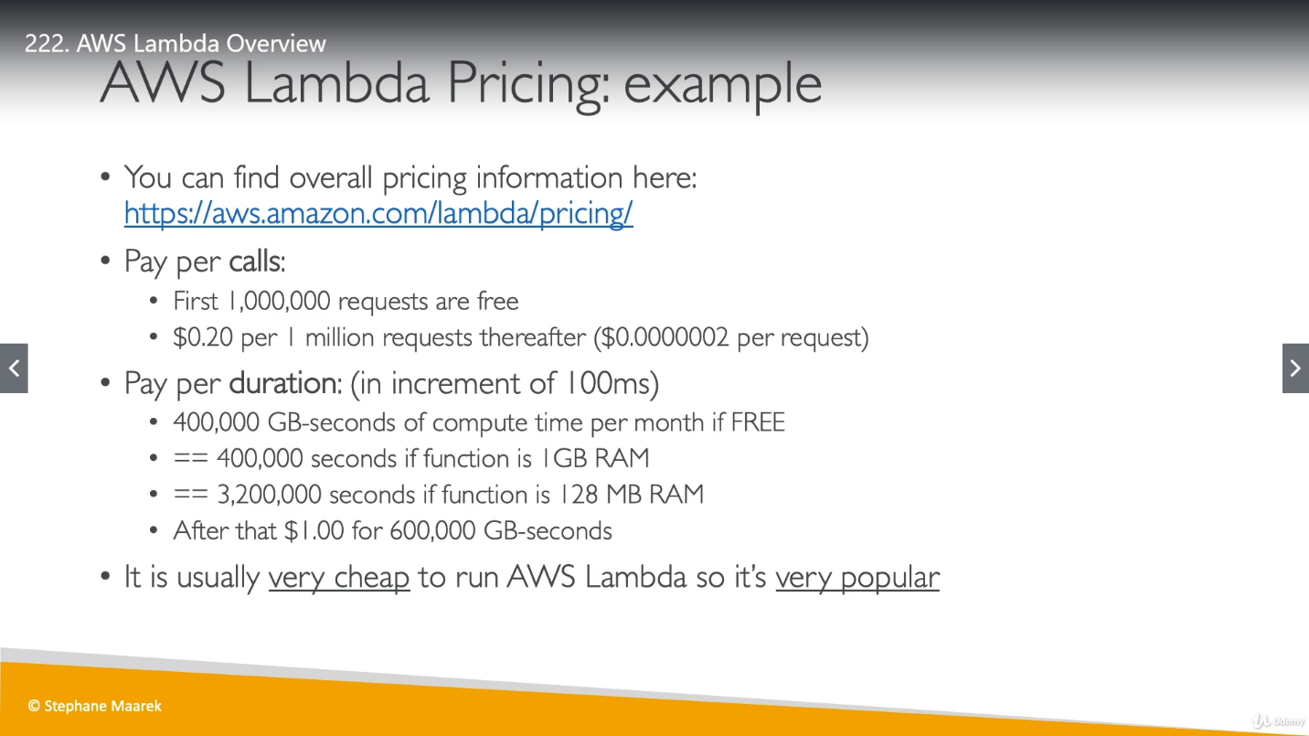

* **Lambda Synchronous Invocation:**

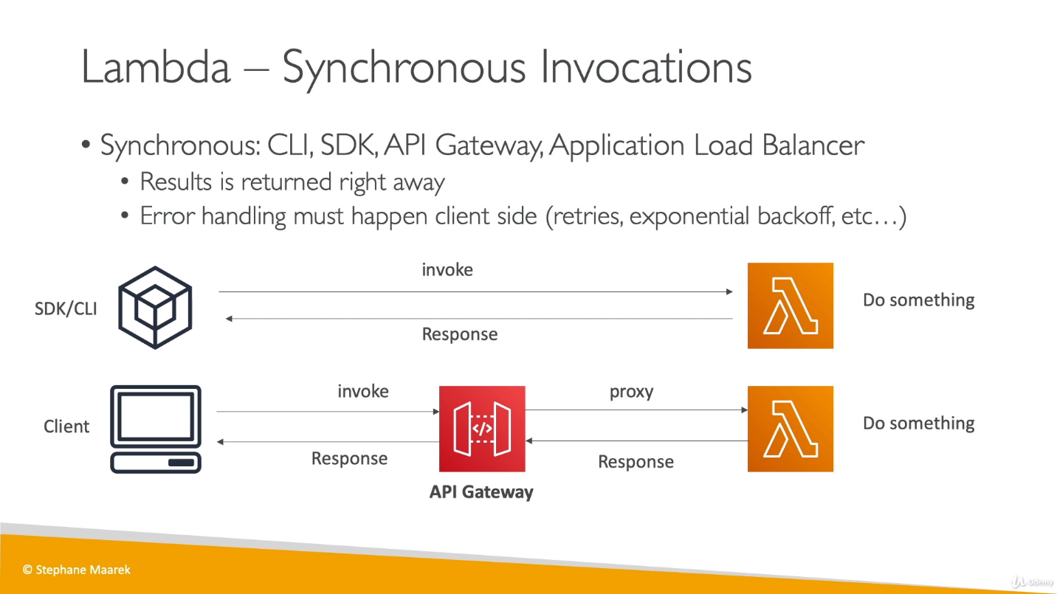

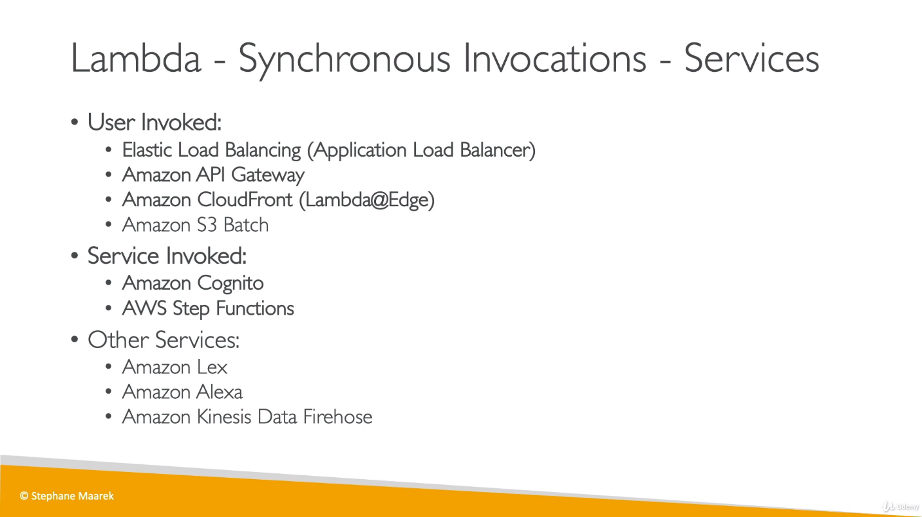

Services mentioned in bold would be discussed for this code.

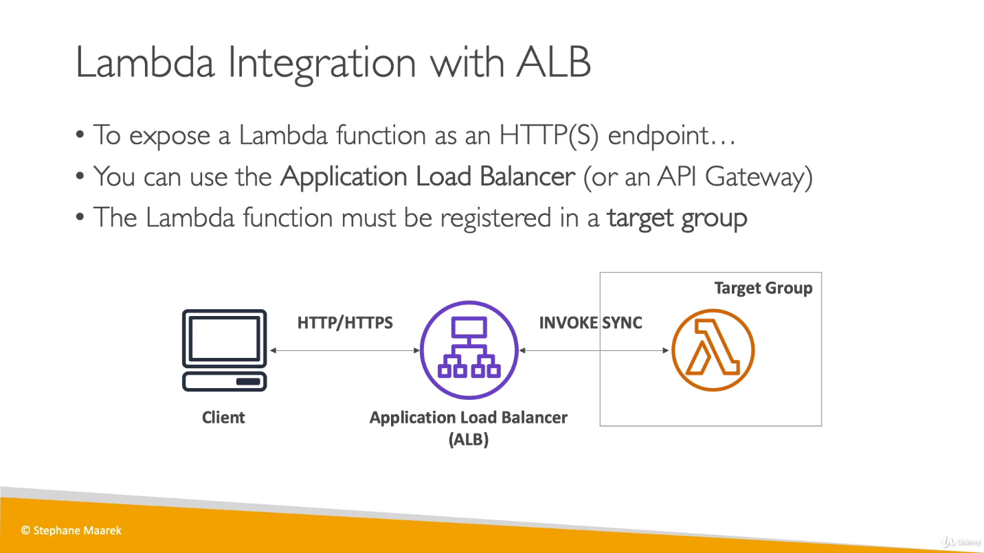

ALB will convert HTTP request into JSON and for output it will convert from JSON to HTTP because lambda will understand JSON format.

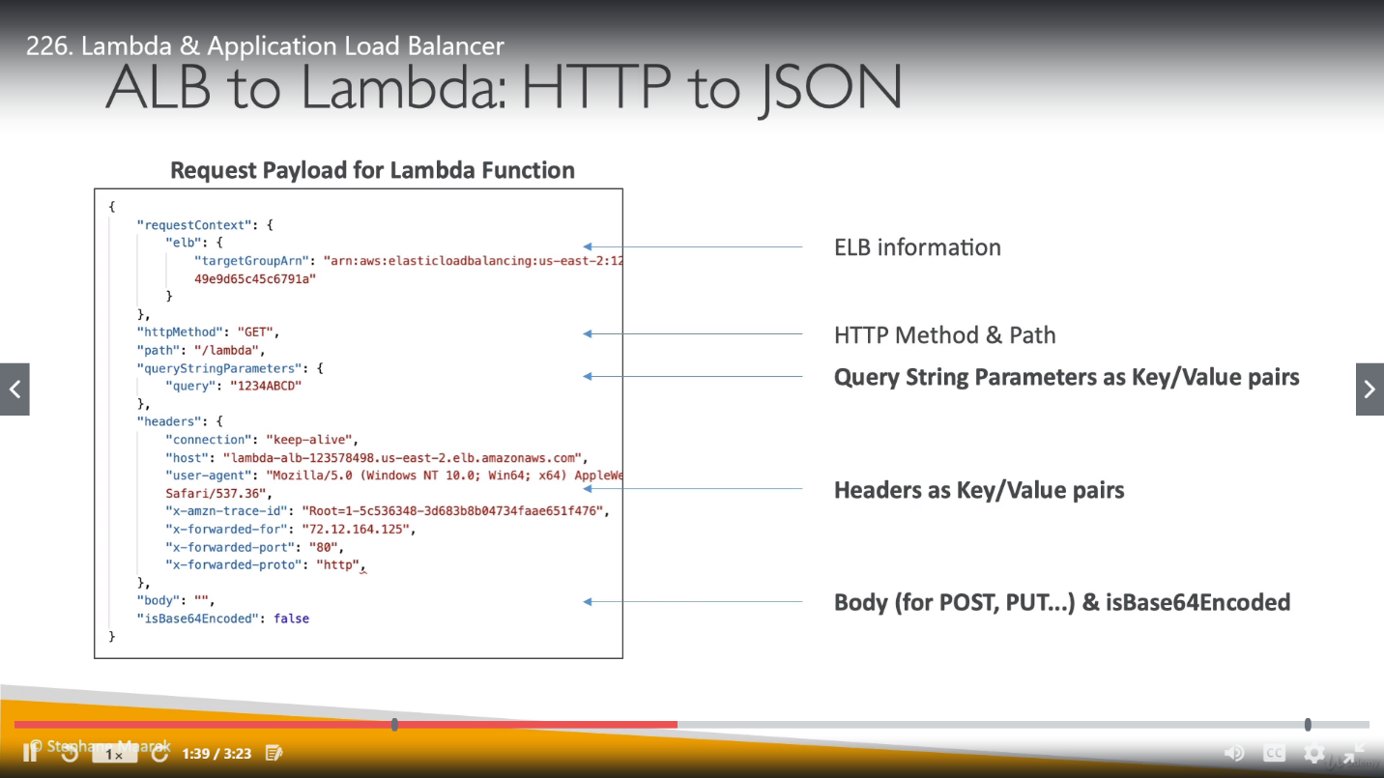

We can see HTTP conversion into JSON in above example which state that Query parameters and Header will go as a Key value pair.

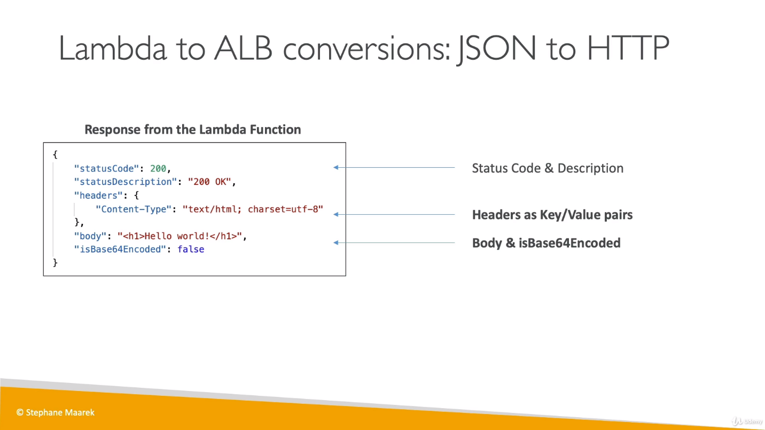

ALB have one more feature while integrating with Lambda, that is multi header value which means we can pass multiple values as a HTTP request. (can be as query parameter or header values).

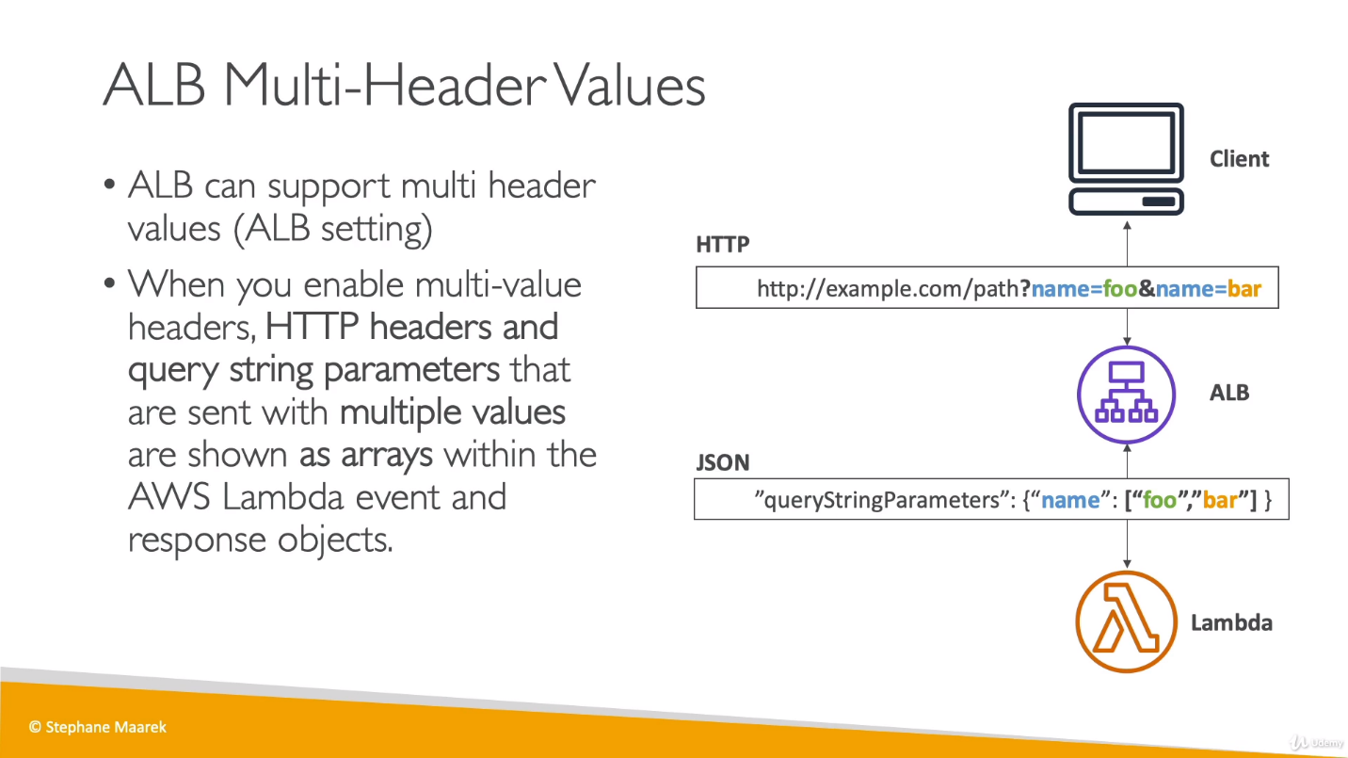

It is best practice to have one IAM role per lambda practice and It is easy to maintain as well.

For ALB and lambda integration, first create lambda function and choose Lambda instead of EC2 instance while creating ALB.

Now if we run test on lambda and hit DNS for ALB on browser, we will get a file which got downloaded and there we can see output from the lambda function. (this is because of content we provided in function return type, if we modify the content, we can see the output on browser instead of downloading a new file).

Once the lambda function executed and we check logs, it will take us to CloudWatch because lambda logs are stored there.

We can see old logs as well whenever we had run lambda function.

**Enable multi header support:**

Go to Target Group for ALB, go to attribute and enable “Multi value header” as below.

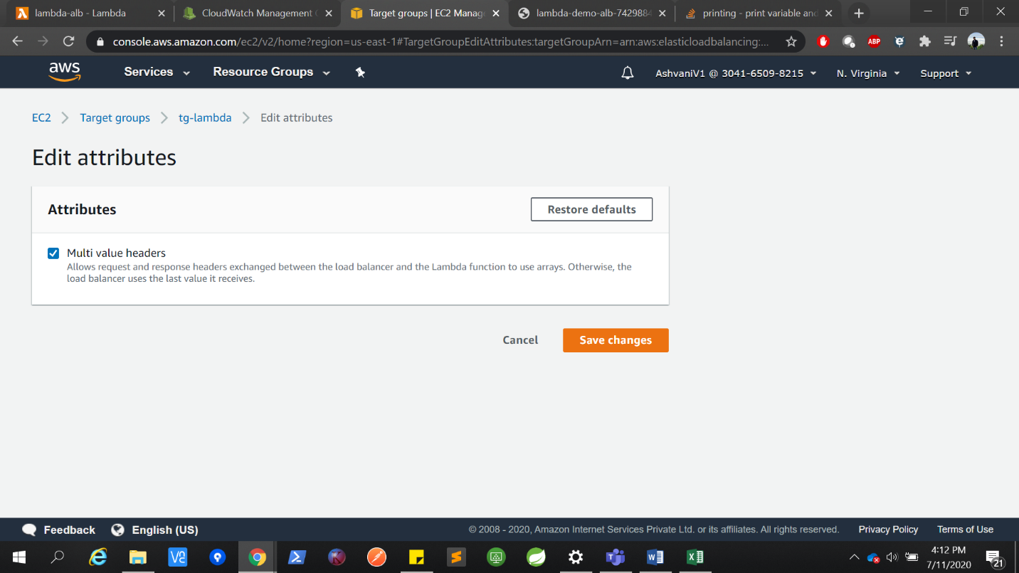

We can modify DNS URL to test multi value query parameter and then verify it in logs.

**Lambda@Edge:**

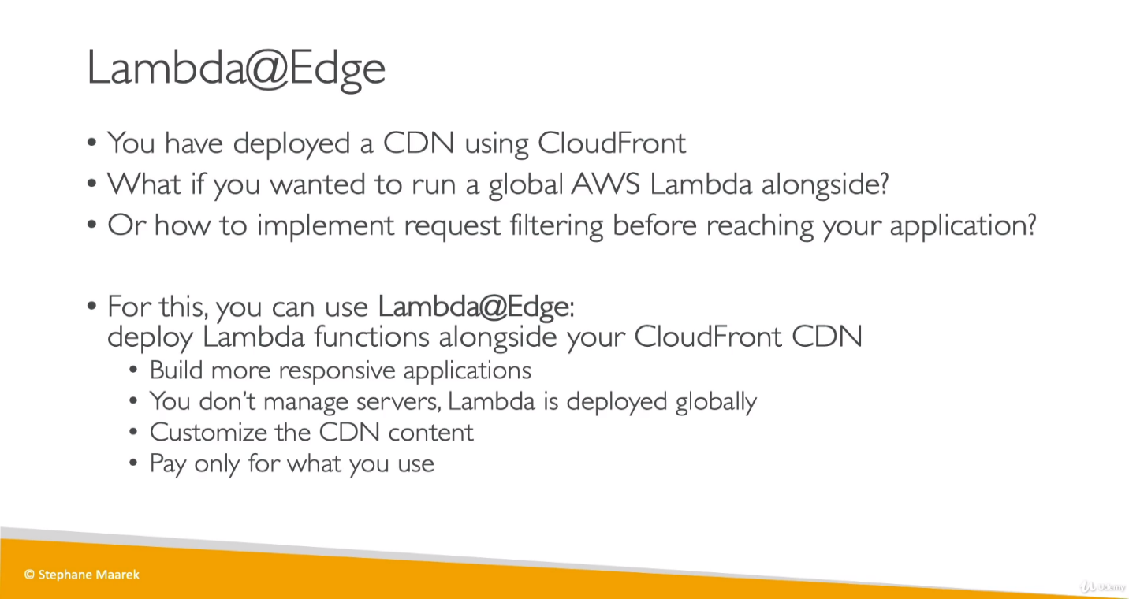

**CDN:** A content delivery network (CDN) refers to a geographically distributed group of servers which work together to provide fast delivery of Internet content. CloudFront is CDN for AWS.

It’s mostly used whenever Lambda is integrated with CloudFront to modify below 4 type of requests.

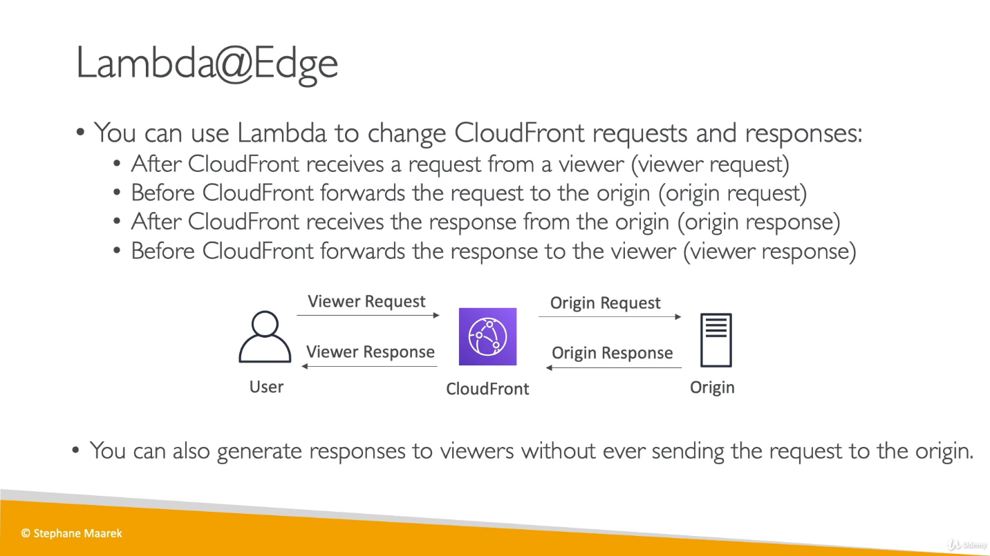

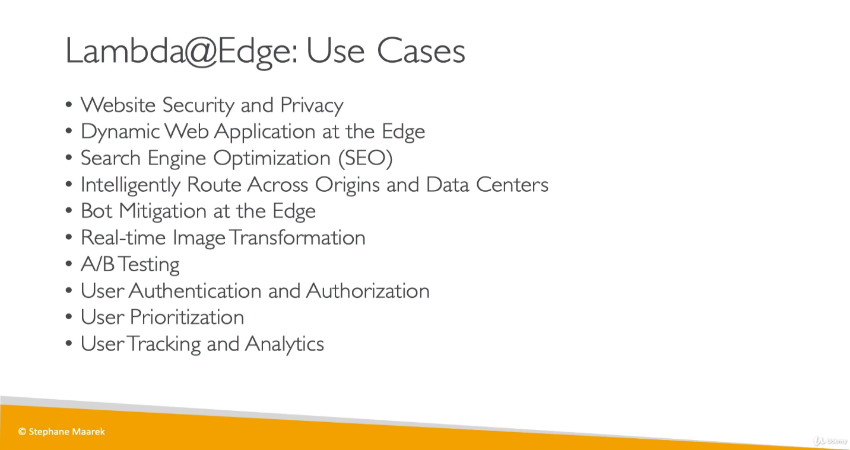

No Hands on is required for Lambda@Edge for exam perspective.

* **Lambda Asynchronous Invocation:**

Few services are suitable for synchronous, but few have more impact with async communication with lambda as below.

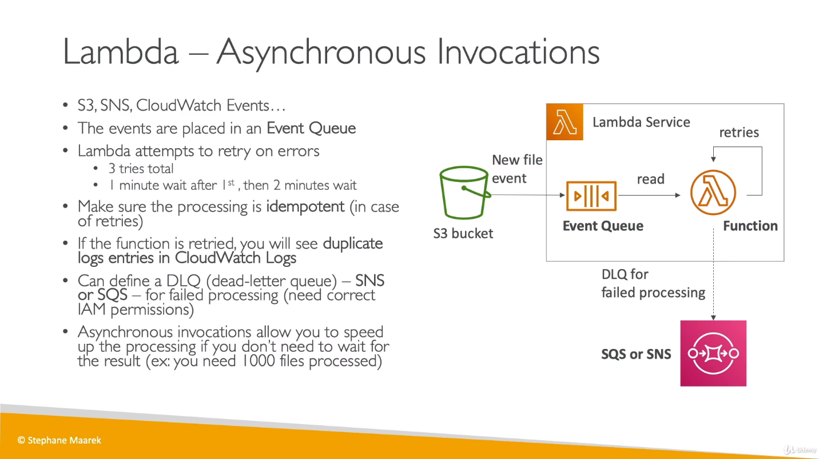

Processing idempotent means if lambda is trying to retry there should not be any changes in result.

In above example, suppose we have an S3 bucket and event notification on buckets goes to lambda function so whenever there is any new file in bucket, an event notification will trigger for lambda function. As there is async mechanism, events will be stored in an Event Queue and lambda function will be reading from this event queue. Lambda function will try to process these events but somehow if things go wrong, lambda function will automatically attempt to retry for 3 time max.

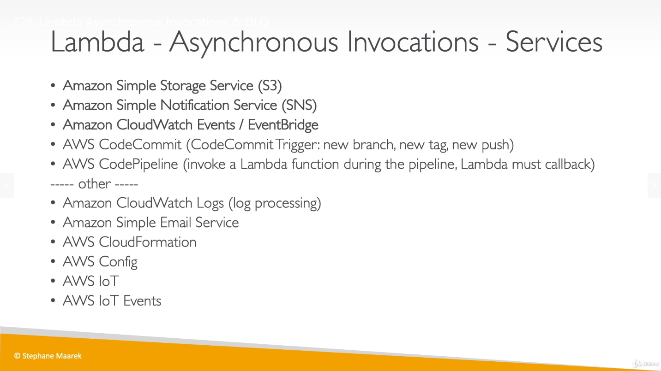

Async invocation has status code 202[The request has been accepted for processing, but the processing has not been completed] as response.

If we are testing async invocation, we have to test it from CLI not from UI. For any failure if we want to store events, later, we can check those events and process them if required, we need to do below:

* Go to lambda function and scroll down, we can see “Asynchronous invocation” option. We can edit it.
* Create an SQS queue and add it as dead letter queue in above.
* Give IAM permission to lambda function to Send messages into SQS queue.
* So now if we try to access lambda from CLI and wait for retry time ([0+1+2] 3 min), we can see events in SQS for failure, later we can analyze them and reprocess if required.
* If we check SQS logs, we can see logs for 3 time requests with failure for retry.

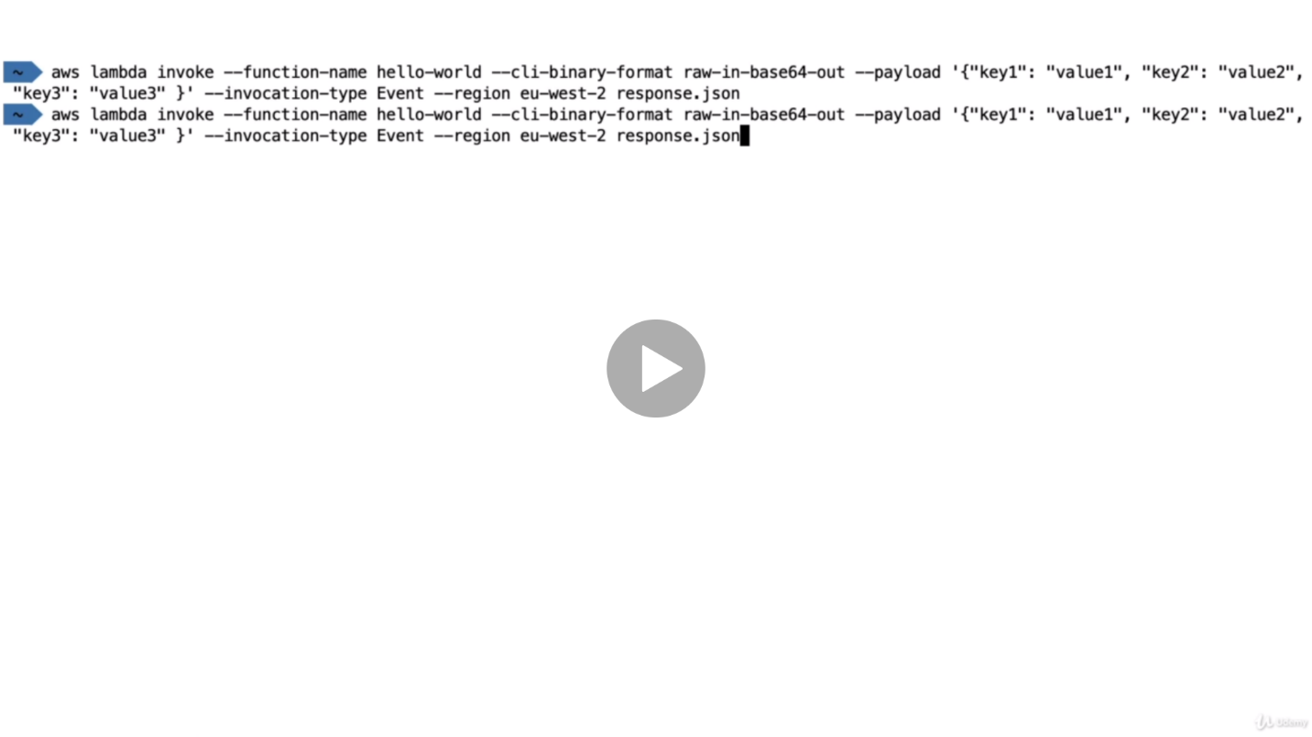

**Amazon EventBridge with Lambda: [Event Bus as SaaS]**

Amazon EventBridge is a serverless event bus that makes it easy to connect applications together using data from your own applications, integrated Software-as-a-Service (SaaS) applications, and AWS services. EventBridge delivers a stream of real-time data from event sources, such as Zendesk, Datadog, or Pagerduty, and routes that data to targets like AWS Lambda. You can set up routing rules to determine where to send your data to build application architectures that react in real time to all of your data sources.

EventBridge makes it easy to build event-driven applications because it takes care of event ingestion and delivery, security, authorization, and error handling for you. As your applications become more interconnected through events, you need to spend more effort to find events and understand their structure in order to write code to react to those events. The Amazon EventBridge schema registry stores event structure - or schema - in a shared central location and maps those schemas to code for Java, Python, and Typescript so it’s easy to use events as objects in your code. You can connect to and interact with the schema registry from the AWS Management Console, APIs, or the SDK Toolkits for Jetbrains (Intellij, PyCharm, Webstorm, Rider) and VS Code.

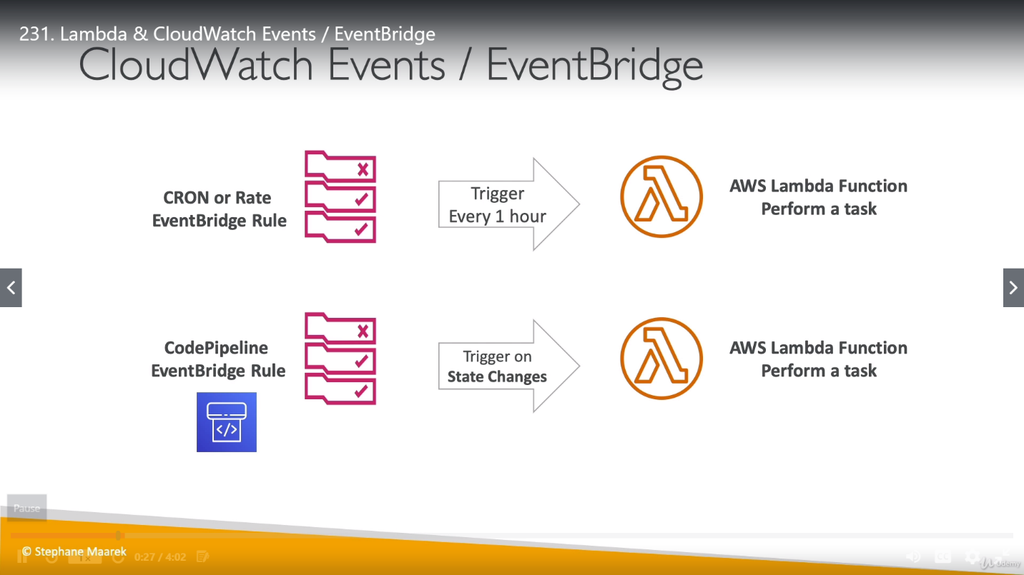

* We can create a lambda function and create an EventBridge for this. (While creating EventBridge, choose target as Lambda Function and attach lambda function to it). We define a pattern for EventBridge to match by choosing either an **Event Pattern** or a **Schedule** to invoke Targets.
* We created EventBridge based on time so it will be invoking lambda function base on time period
* We can see, who can invoke lambda function by below UI or by checking resource based policies for lambda function to see who can access this function under permission tab.
* Invoke of lambda will come with pink icon as below and source of lambda will come with green icon as in S3 bucket example .

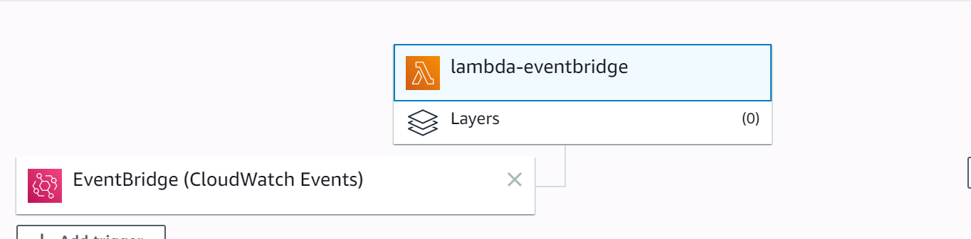

* Imp** Once we created a rule and attached a Lambda function to it (in this example we created schedule based rule for 1 min interval), EventBridge always be looking for events on lambda function and same logs will be going into S3 buckets. [Even if we are not running lambda function explicitly, it will continuously be checking for events on lambda function]

<https://aws.amazon.com/eventbridge/faqs/>

**S3 Event Notification integration with Lambda:**

* We can get notified whenever an S3 object is get created, removed, restored or replicated.
* Filtering can be done based on prefix or suffix.
* Use case are like generate thumbnail images of every image uploaded into S3.
* So now we have any above mentioned event in S3 and S3 can send 3 things: **SNS** (further multiple SQS queue), **SQS queue** (lambda function read from SQS queue) and **Event notification,** directly invoke our lambda function (async).
* Sometime there is possibility to lose these events so to prevent this misshapen we should enable versioning on our bucket. For ex.(two write calls on same object at same time then there might be one notification without versioning).

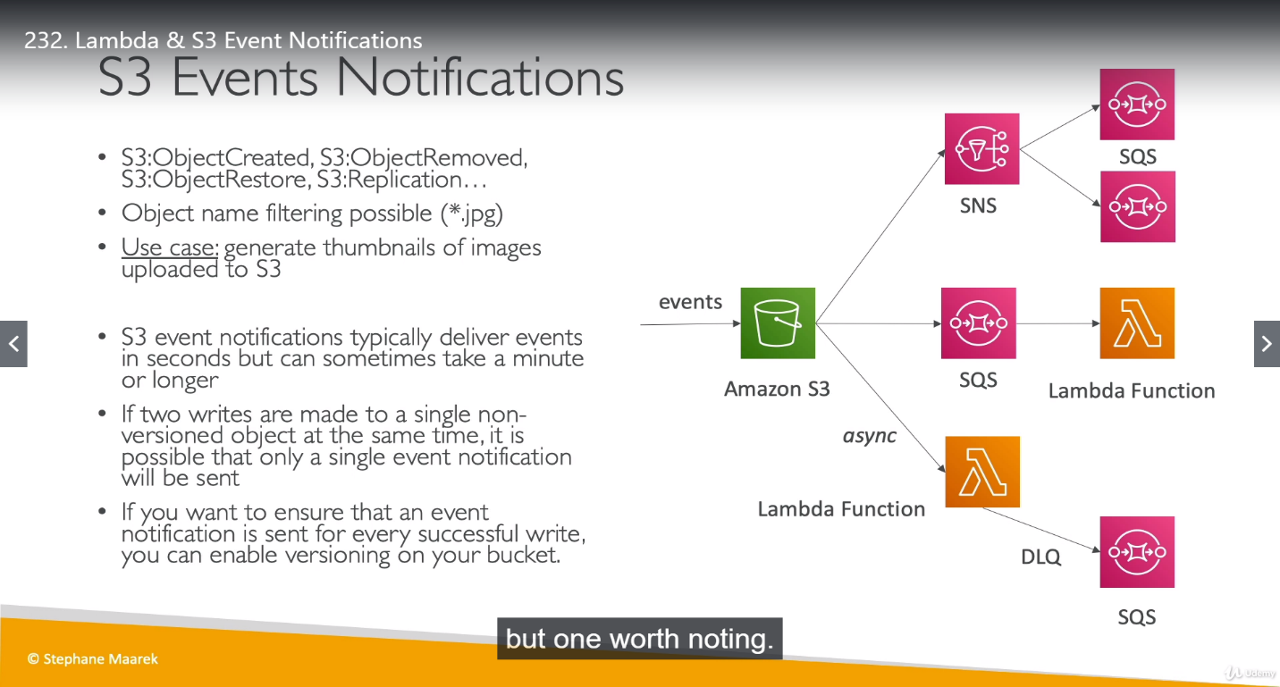

**Simple example**

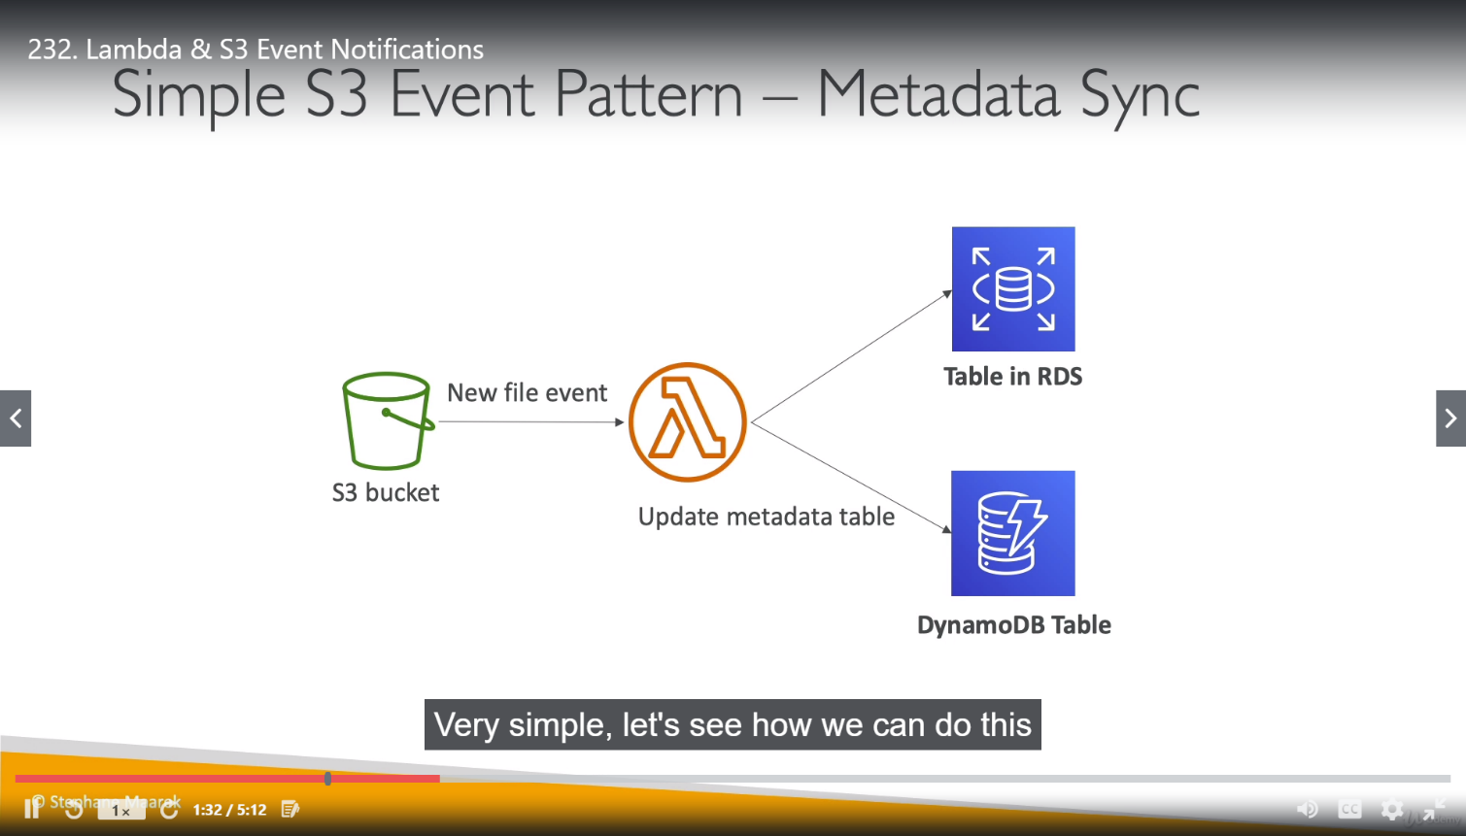

* In above example, there is an event on S3 bucket, and a notification comes to Lambda later can stored in DynamoDB or RDS.
* Once any event triggered on S3, event will be trigged and captured by Lambda function so we can see many details about the event in CloudWatch logs.(printed based on lambda function), so this information is enough to do operation in lambda function (as we created Python lambda function but it can be in any other language as well) based on event happened in S3.

Lambda can process events in aws using source mapping as well:

* Here lambda need to ask service to get/polled records and then records will returned to lambda.
* Lambda function invoked synchronously in this case.
* Below example, recorded are fetched from Kinesis.

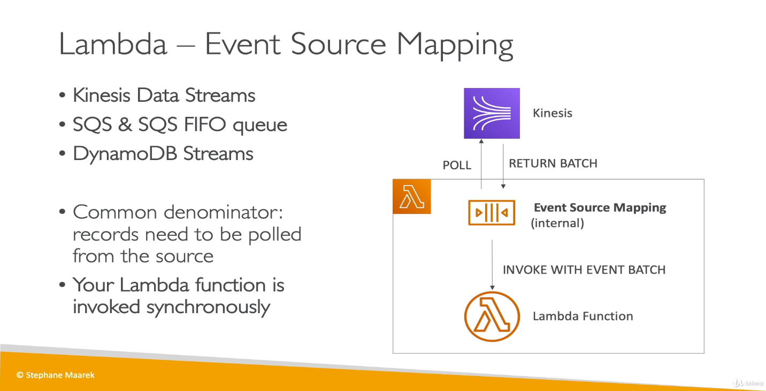

* There are 2 categories of Event Source mapper that are **Queues and Streams**.
* **Streams:** For Kinesis and DynamoDB
  + Event Source mapping will create an iterator for each shard (Kinesis or DynamoDB shard) and the items will be processed in order at shard level.
  + We can configure where to start read from like from beginning or from timestamp.
  + Once the data read from shard it will not be removed so other resources can also read data.
  + If we have low traffic and we are using batch, then there will be in-order processing at partition key level. So, if specify a partition key it will not be read in-order for entirely for shard but each key within the shard will read in order. (as in below diagram 1, 2 and 3 are keys).
  + As batches can run into parallel so we have parallelized processing for stream and lambda function in below example.

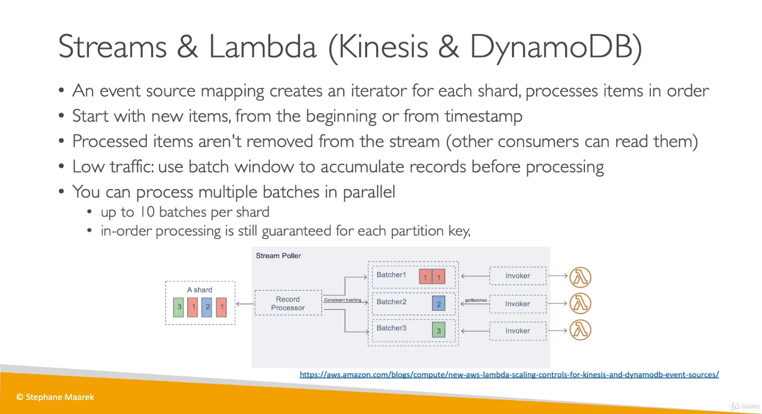

* + Having error in batch, can block the processing, so to ensure processing, processing for the effected batch is paused until error is resolved.

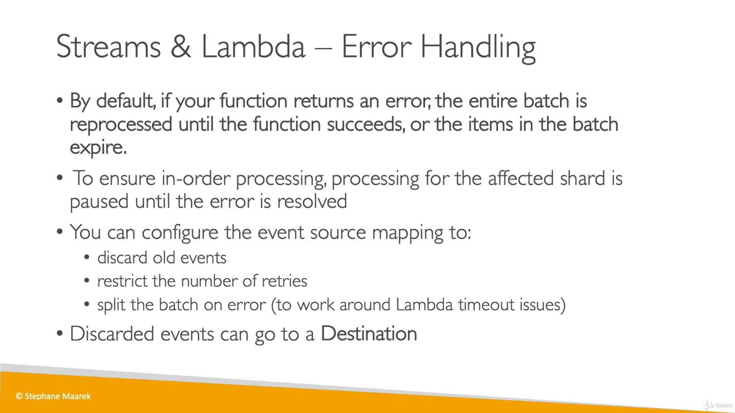

* **Queues:** For SQS and SQS FIFO
  + SQS will be pulled by Event Source mapping and once the batch is returned, lambda function will be invoked synchronously with the event batch.
  + Here if we want to setup DLQ for any problematic message then we have set it up on SQS not on lambda as usual in other cases because DLQ on lambda only works for async notification and this is sync invocation.

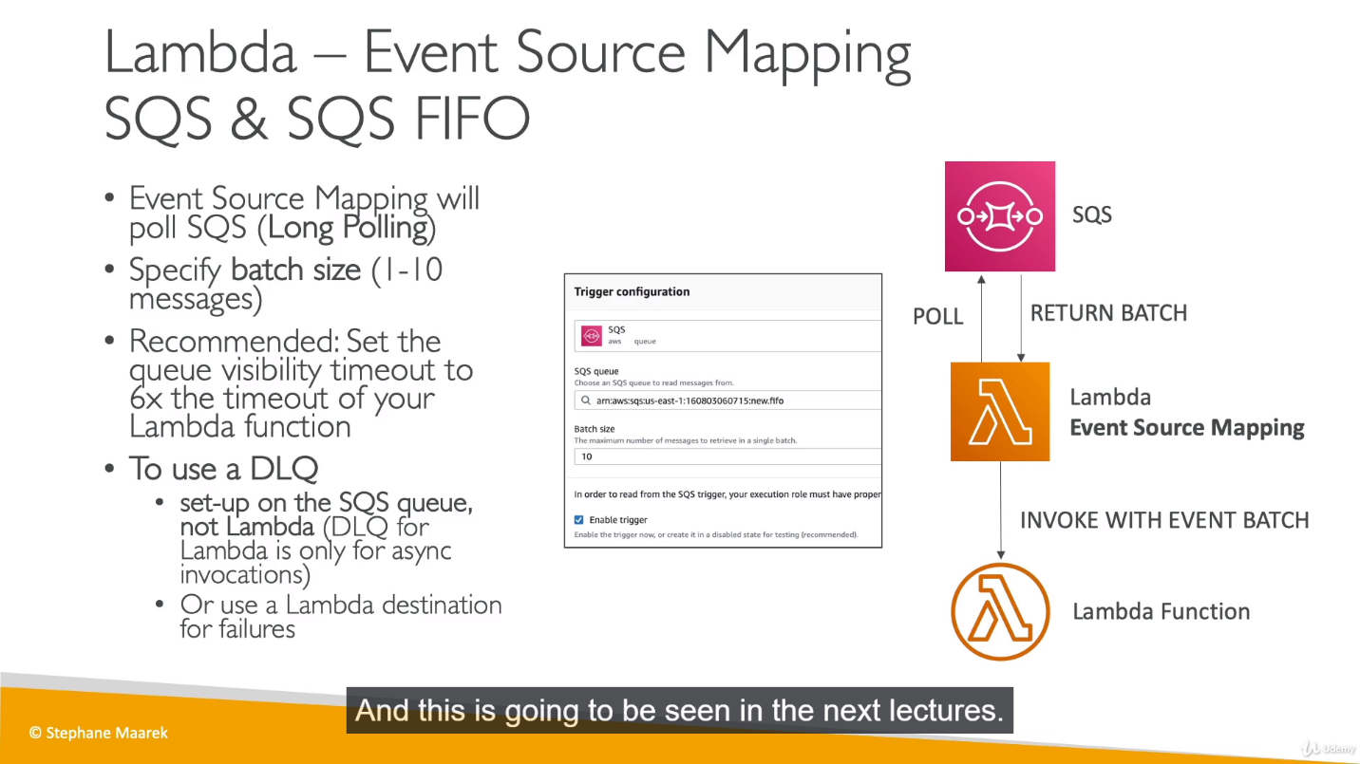

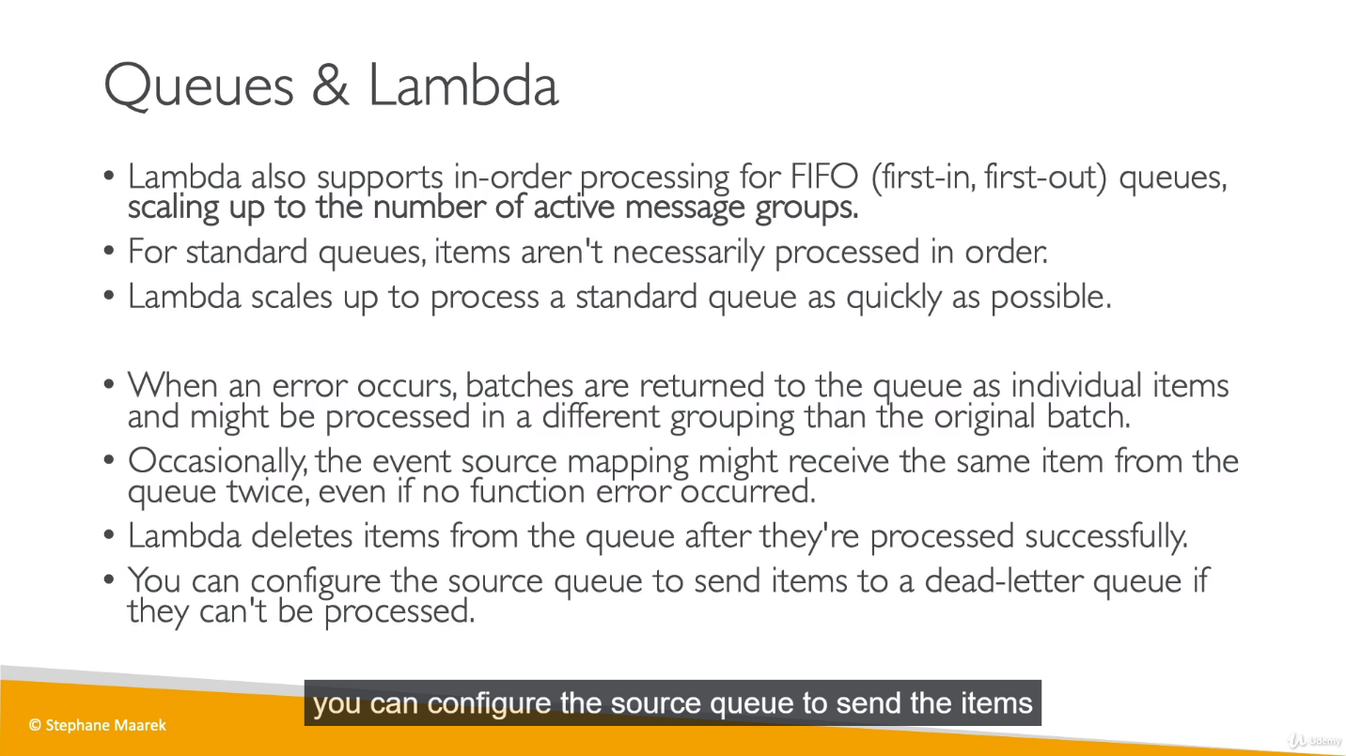

* + As mentioned above, we can receive same message twice from the queue even if there is no error, so we need to make sure to have idempotent processing for lambda function in case it happens .

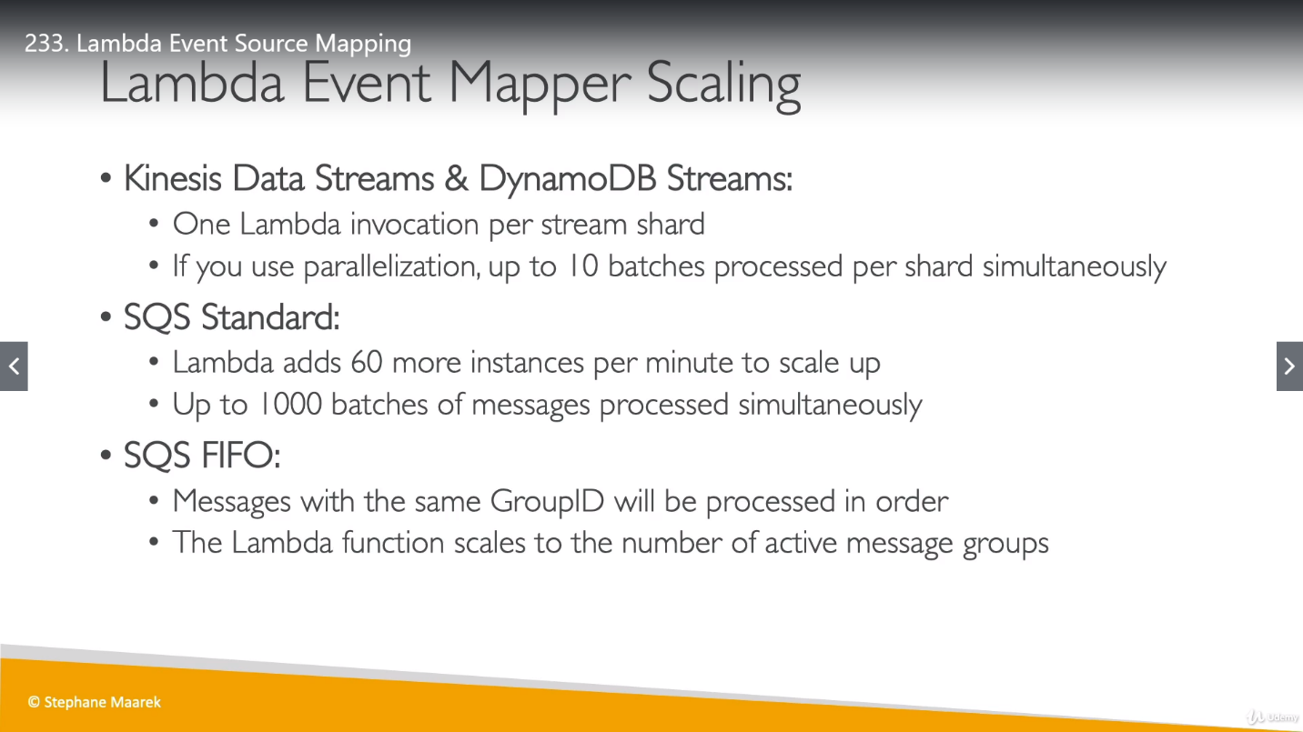

**Lambda Destinations:**

This been introduced recently to notify about success or failure of an **async invocation** or **event mappers**.

* **For async invocation:** This is similar to DLQ where we send notification for success or failure but in DLQ we have only 2 options either send notification to SNS or SQS. We have multiple destination choice in case of Lambda Destinations.
* **For Event Source mapper:** Used when we have event Batch that gets discarded because we can’t process it So we can send this event batch into Amazon SQS or SNS. In below example, we are reading data from Kinesis, and if we don’t succeed, instead of blocking of our entire processing of Kinesis Data Stream we can send the discarded event batch into our failed Event Destinations.

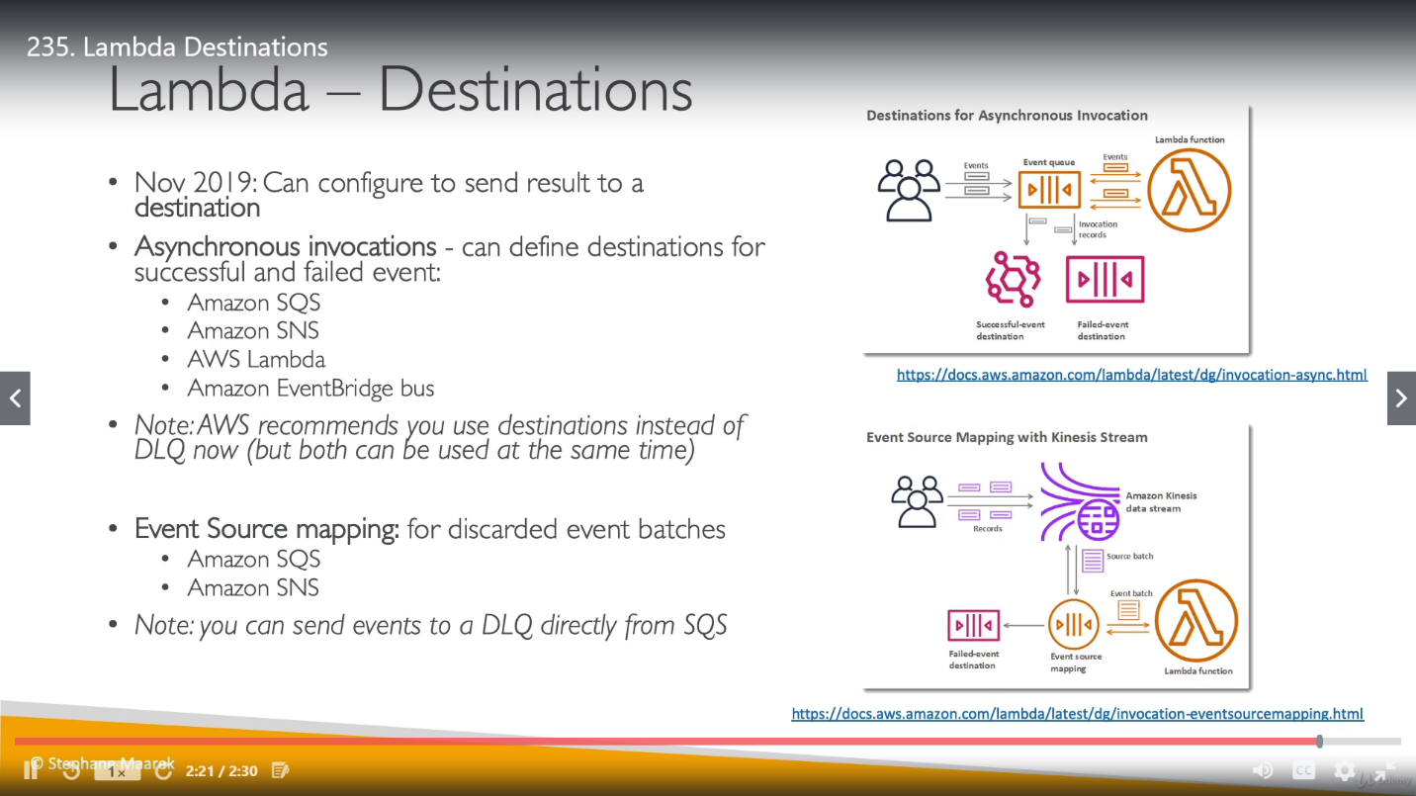

**Lambda Execution Roles and Policies:**

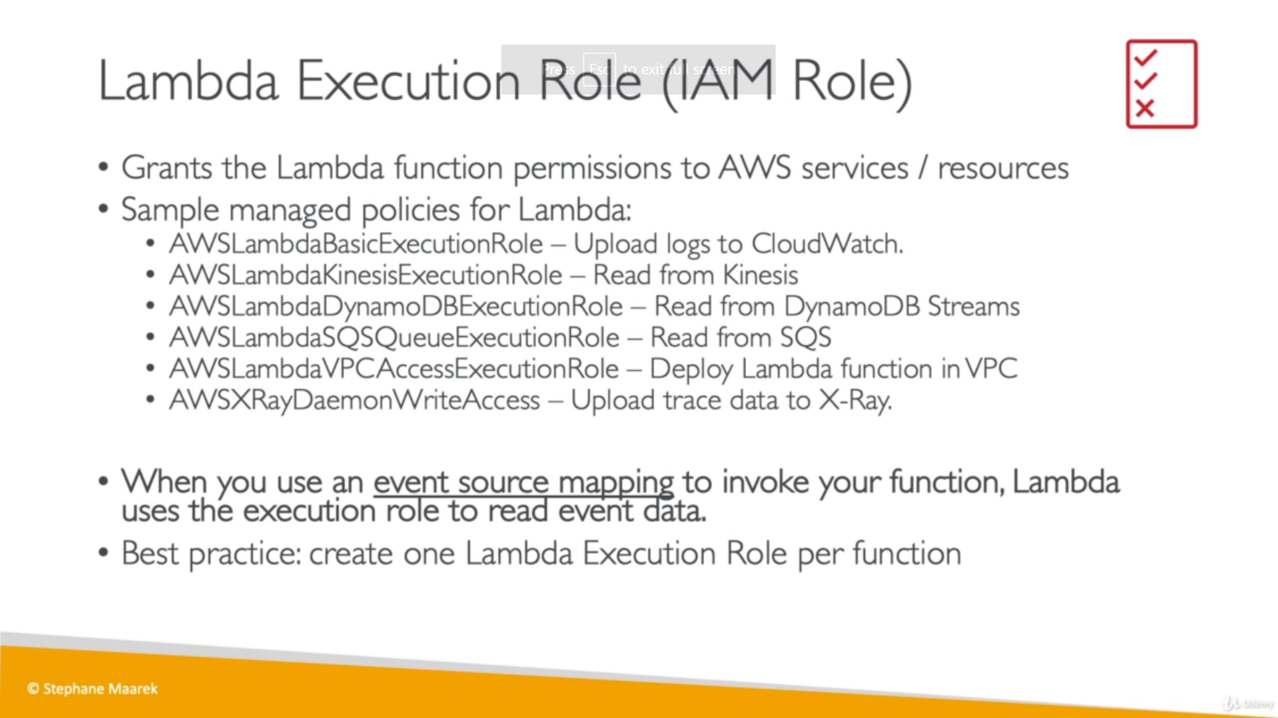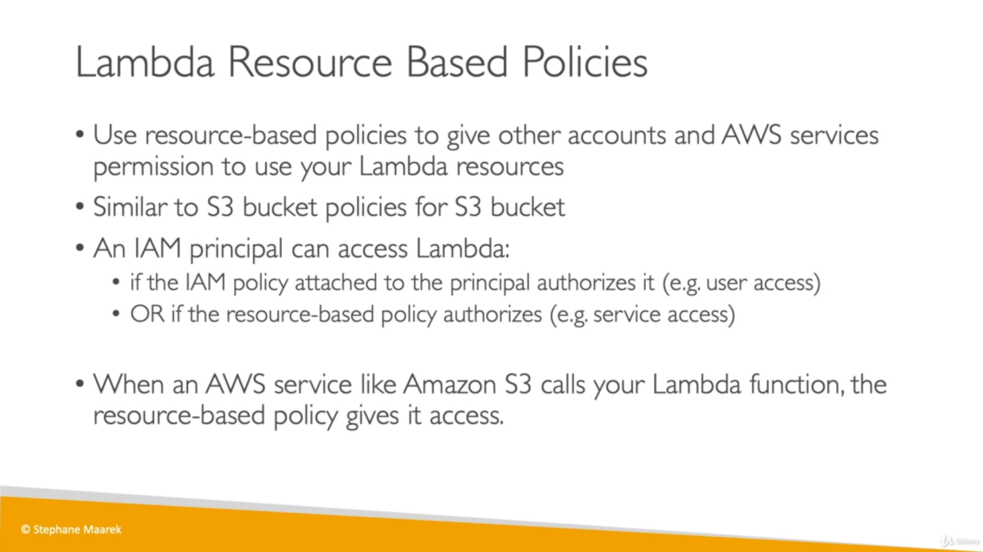

**Lambda Environment Variables:**

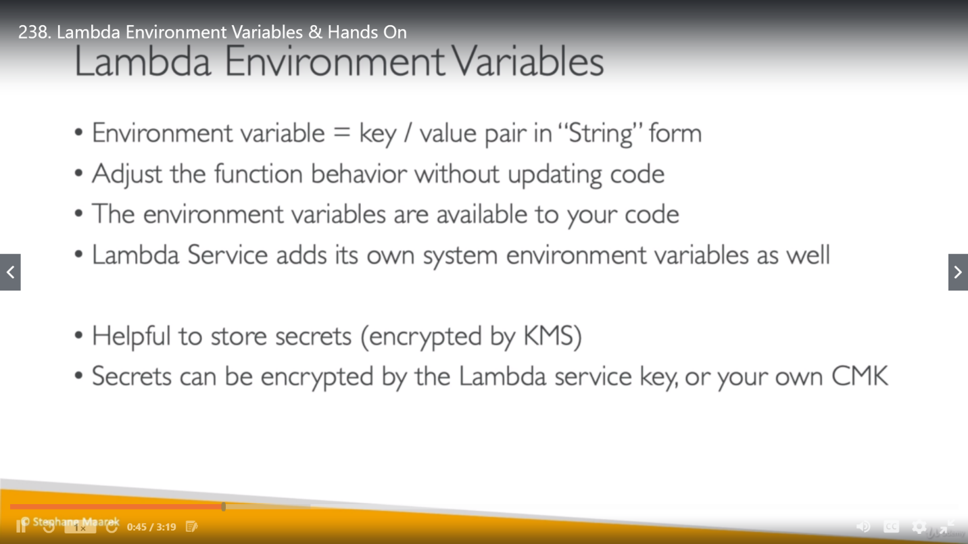

**Lambda Logging and Monitoring:**

We haven’t seen cloudwatch metrics yet but there are there and will be seeing them later.

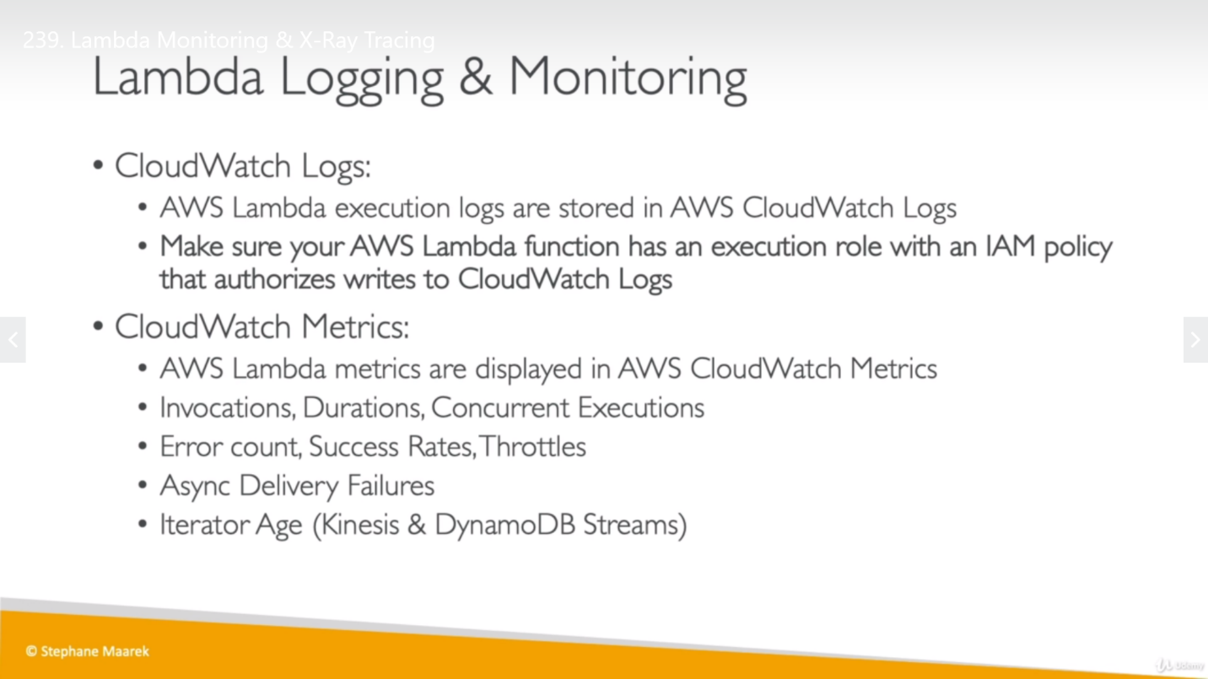

**Lambda Active Tracing:**

Enabling X-Ray in Lambda is known as Active Tracing.

Here Environment variables to communicate with X-Ray is important. AWS_XRAY_DEAMON_ADRESS is latest in all of them and it represent where is the IP and port of latest daemon is running for lambda function. These env variables can be accessed in same way as we accessed other user define env variables.

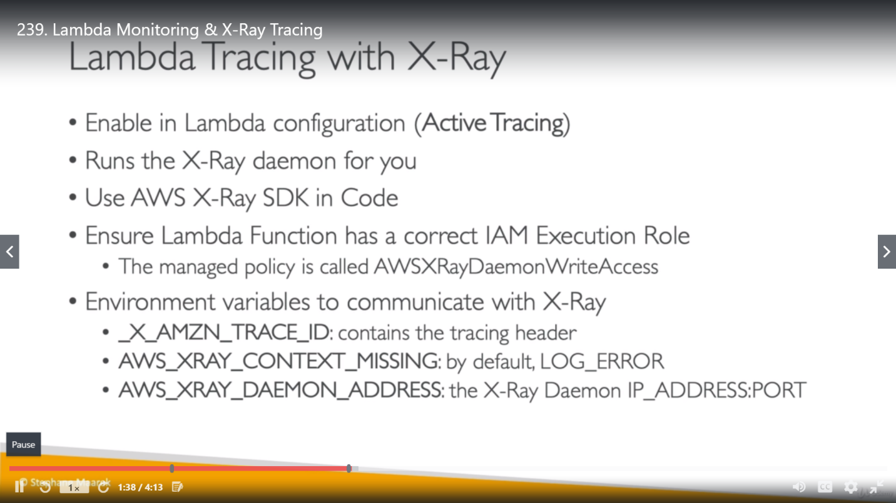

We should have a policy attached to our lambda function to use it. (have both options either AWS can do this for us, or we can do it manually)

**Lambda in VPC:**

* By default, Lambda function launched outside VPC. (it is in VPC owned by AWS).

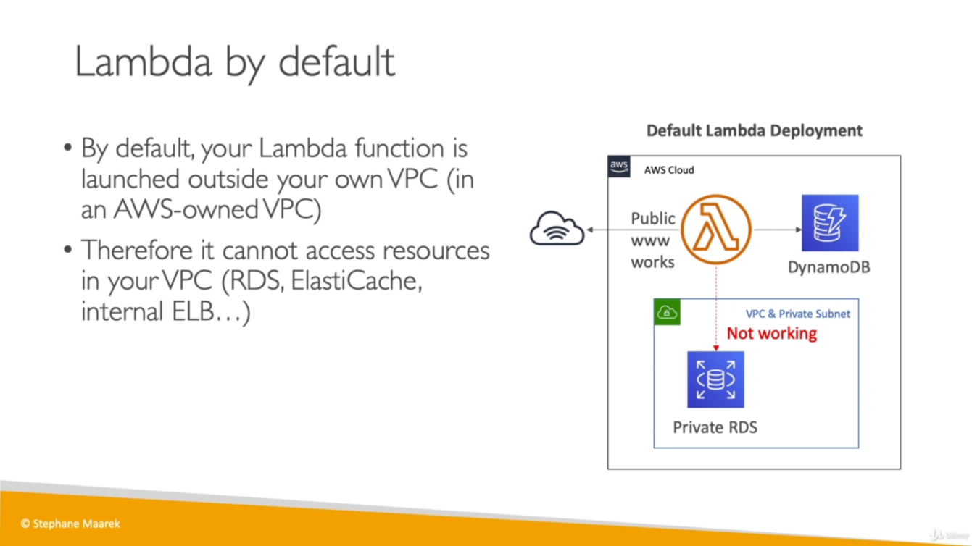

* By default, Lambda can’t access resources from our VPC.
* To access a VPC resource by lambda, we can define VPC ID, Subnet and Security Group in Lambda function so lambda function will create an **ENI** in our selected Subnet. To do this lambda function should have required roles.
* ENI is behind the scene; we don’t see it.

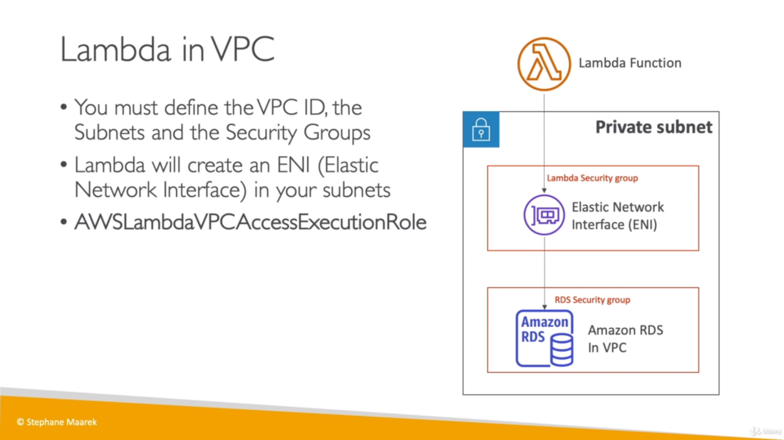

* **Caveat:** Lambda function in private/public subnet of VPC can’t access Internet in lambda. (EC2 instance in public subnet has internet access).
* If we want to use Internet access in private subnet for lambda, we have to define NAT Gateway.
* If we want to use other Amazon service like Dynamo DB from Lambda inside private subnet, we have two options: VPC endpoints to privately access Dynamo DB, second, use NAT Gateway as used for internet. In case of NAT Gateway, NAT will be talking to Internet Gateway of VPC and Internet Gateway will be communicating to External API.
* If we want to access DynamoDB, we can use either IGW through public route. If we want to access Dynamo DB privately

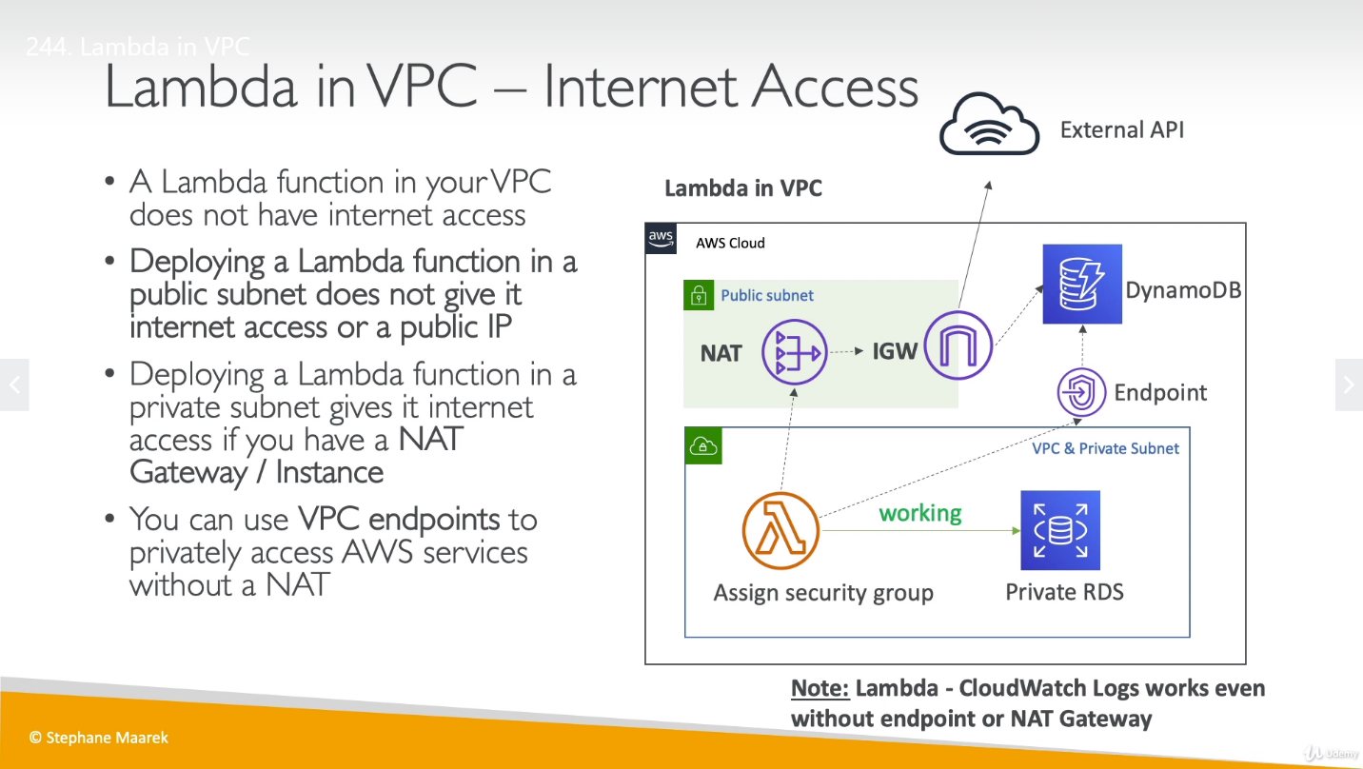

* **IGW:** An internet gateway is a horizontally scaled, redundant, and highly available VPC component that allows communication between our VPC [VPC resources] and the internet.
* **NAT:** A NAT device forwards traffic from the instances in the private subnet to the internet or other AWS services, and then sends the response back to the instances.
* The instances in the private subnet can access the Internet by using a network address translation (NAT) gateway that resides in the public subnet. A NAT gateway must be created in a VPC with an Internet Gateway. Otherwise, the NAT gateway won't work.

We can create a Lambda function and assigned it into our VPC. Assign required roles and SG to it. We can see an ENI would be created behind the scene for this lambda function.

**ENI:** AWS Elastic Network Interface is simply a virtual interface that can be attached to an instance in a Virtual Private Cloud (VPC).

If our lambda function has too many things to process and it needs more vCPU then we simply need to improve RAM of lambda function and it will improve vCPU. [We can edit RAM capacity for our Lambda function 128MB – 3008MB], We can set timeout for Lambda as [3s – 15min]

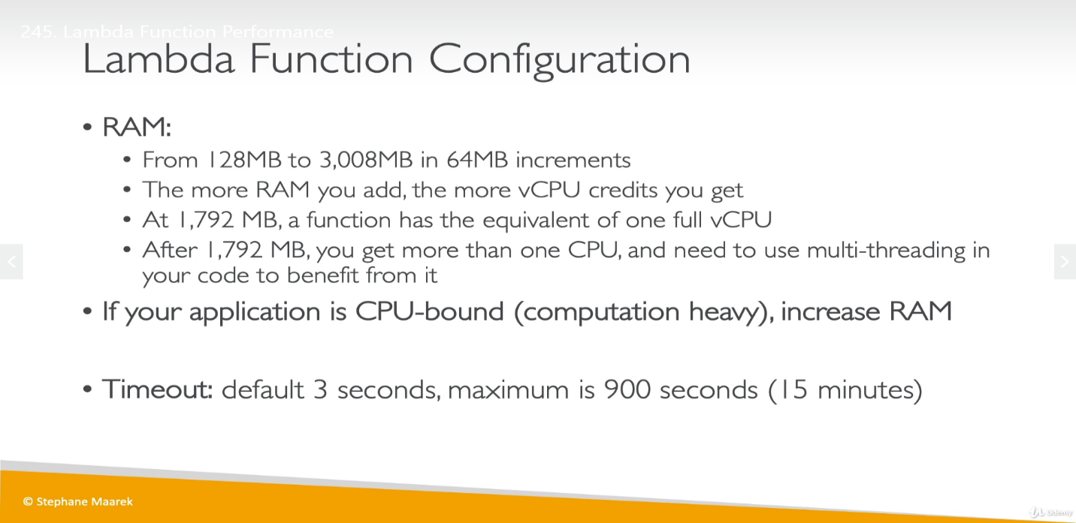

**Lambda Execution Context:** A temporary runtime environment to initialize external dependencies as DB connection, HTTP and SDK clients, are required for our Lambda and this can also be used by other lambda functions as well.

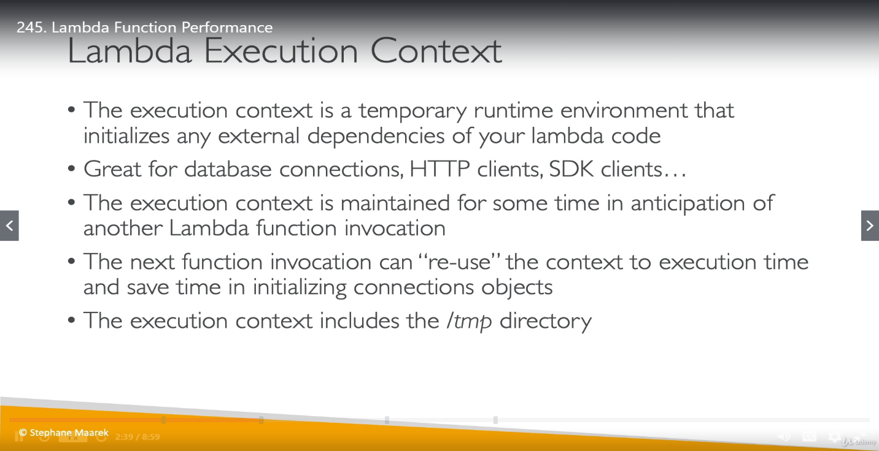

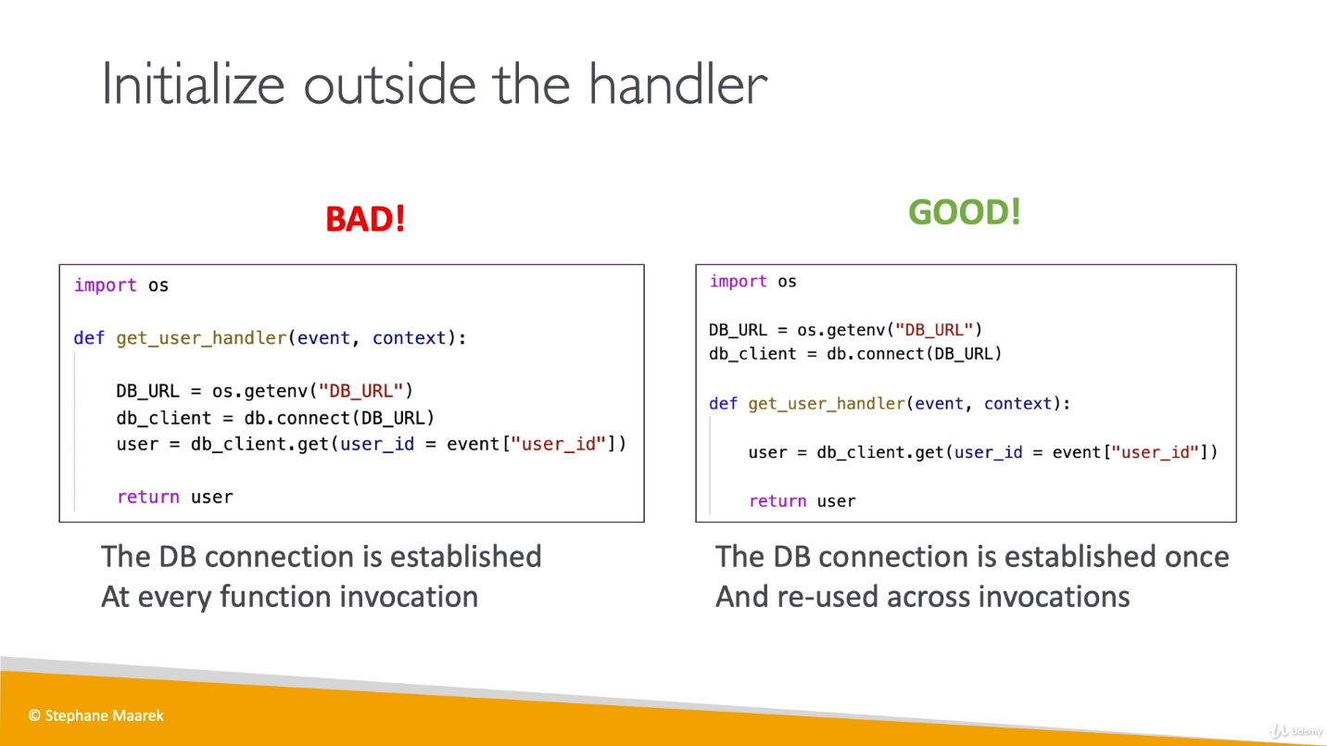

Anything which takes more time should put outside of our lambda function and reusable. like DB connection (If using inside function and function is getting called multiple time then DB connection will be stabilized for each call which will take time).

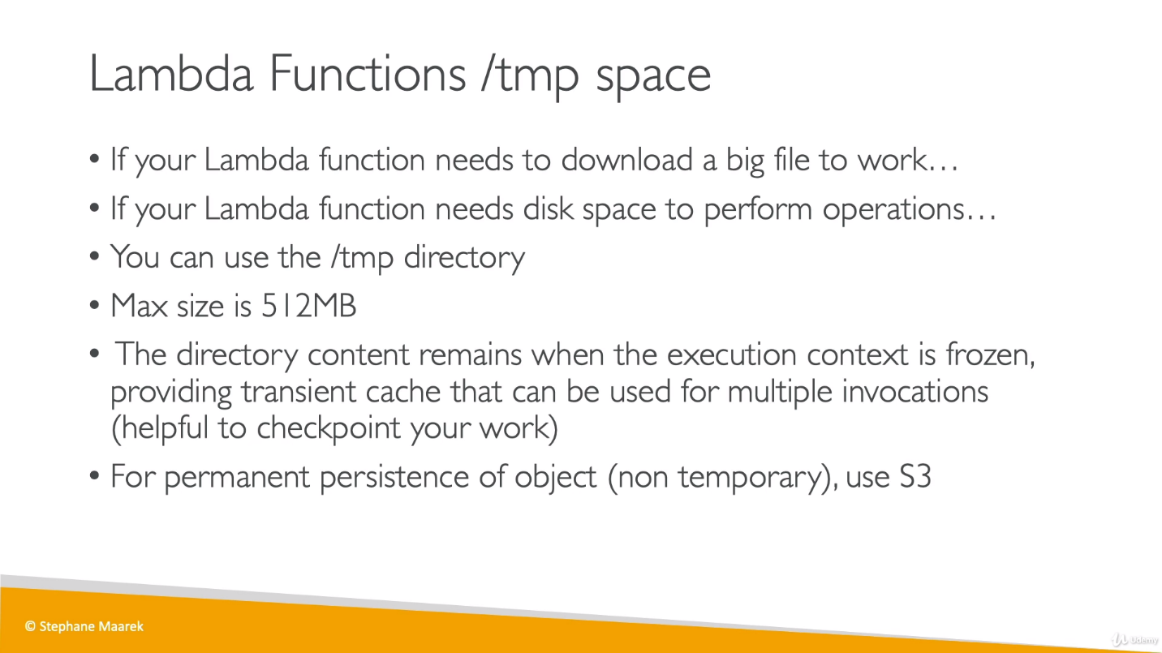

If we have a huge file which is getting downloaded by lambda or by getting used by lambda [but we no need to persist it for long time], then we can use tmp directory provided by AWS for Lambda function.

If we want to store file permanently then we can use S3 bucket.

**Lambda Concurrency and Throttling:**

Concurrency is the number of requests that your function is serving at any given time. When your function is invoked, Lambda allocates an instance of it to process the event. When the function code finishes running, it can handle another request. If the function is invoked again while a request is still being processed, another instance is allocated, which increases the function's concurrency.

We can limit concurrency by defining reserved concurrency and If requests reach more than this limit called as Throttle.

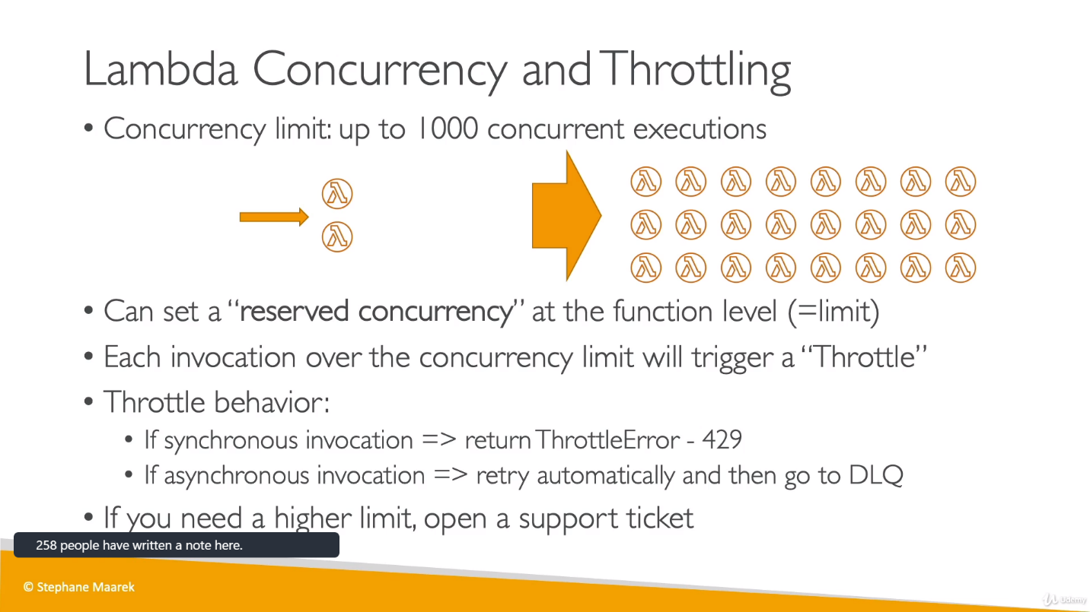

There is a problem if we don’t set concurrency limit as suppose we have 1000 request coming to single function so other function will not serve request and they will throttle out.

Below example is having 3 lambda functions where first one is getting 1000 requests.

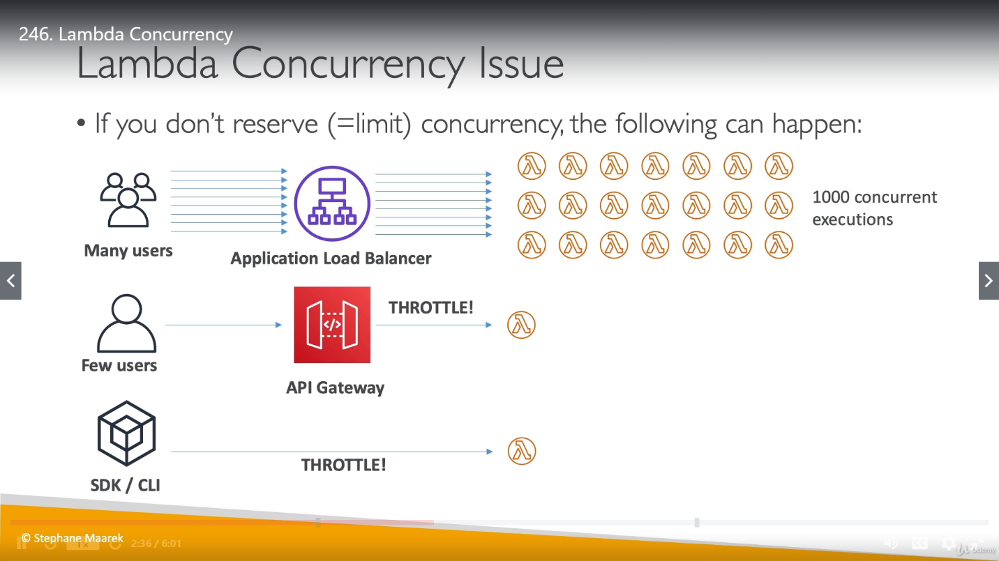

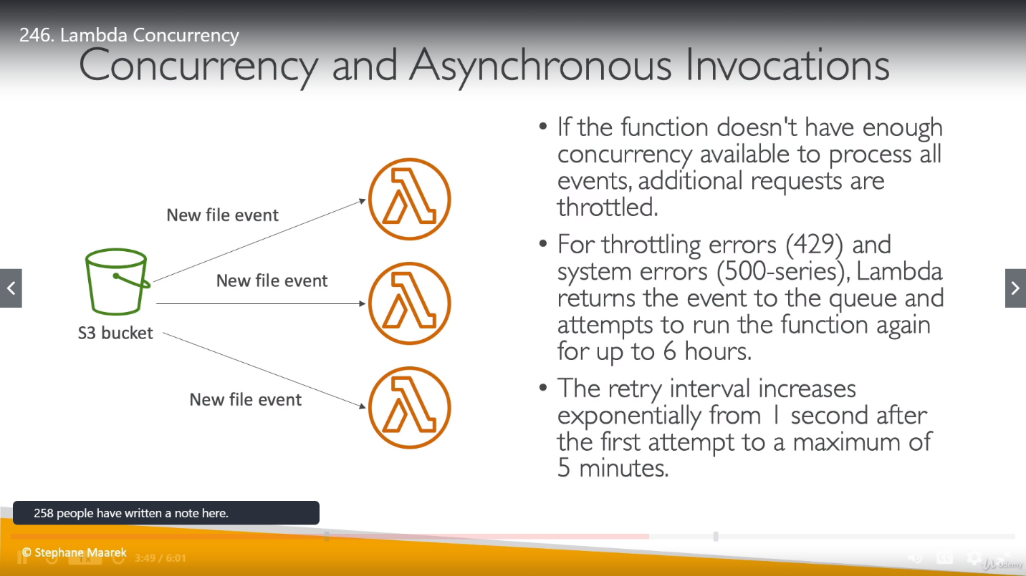

If we have reserved concurrency as 0 for any of function, then it will not allowed us to run it at least once. [This is the case where our function is always Throttle].

Concurrency limit for out account is 1000.

**Lambda Function External Dependency**

We have to take external dependency [based on language which we are using in our function] and package it alongside our code and zip it together.

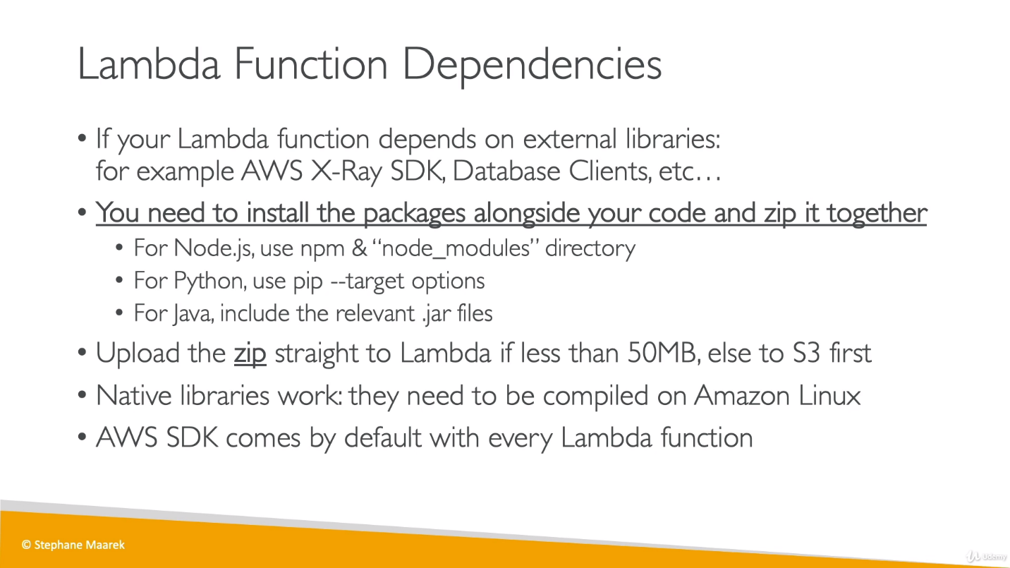

**Lambda with CloudFormation**  
CloudFormation is used to upload lambda function and we have 2 ways to do it.

1. **Inline:** Define lambda function inline in our CloudFormation template.

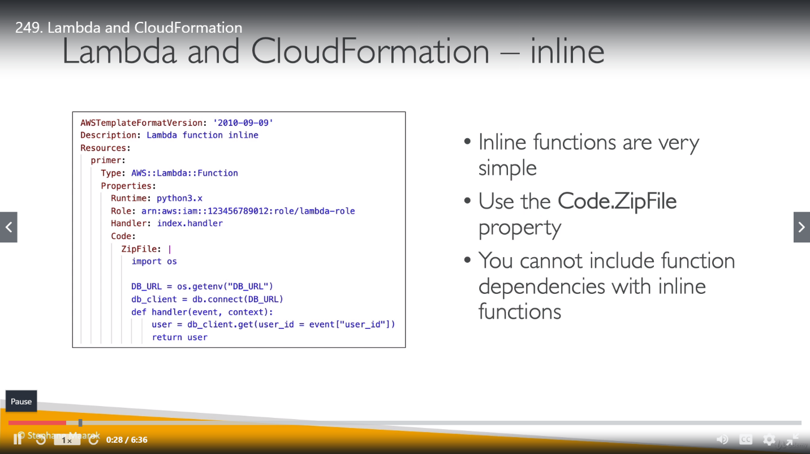

1. **Through S3 Bucket:** Store Lambda function zip in amazon S3, refer S3 zip location in CloudFormation code. S3 zip is [S3 bucket, S3 key and S3 Object version].

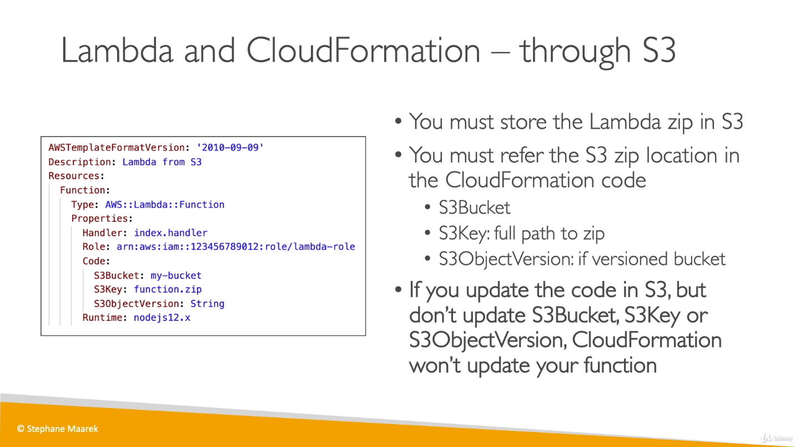

As we are storing Lambda in S3 and suppose we update Lambda so does S3, then we must update CloudFormation template as well for latest changes updating.

We have to create Bucket to store Lambda and it should be created in same reason where Lambda exists.

Now we have uploaded our function zip file into S3 so we are good to create CloudFormation template. So, go to CloudFormation services and create a Stack, upload yaml which have all details for lambda function along with roles. Next is we have to enter 3 parameters as below :

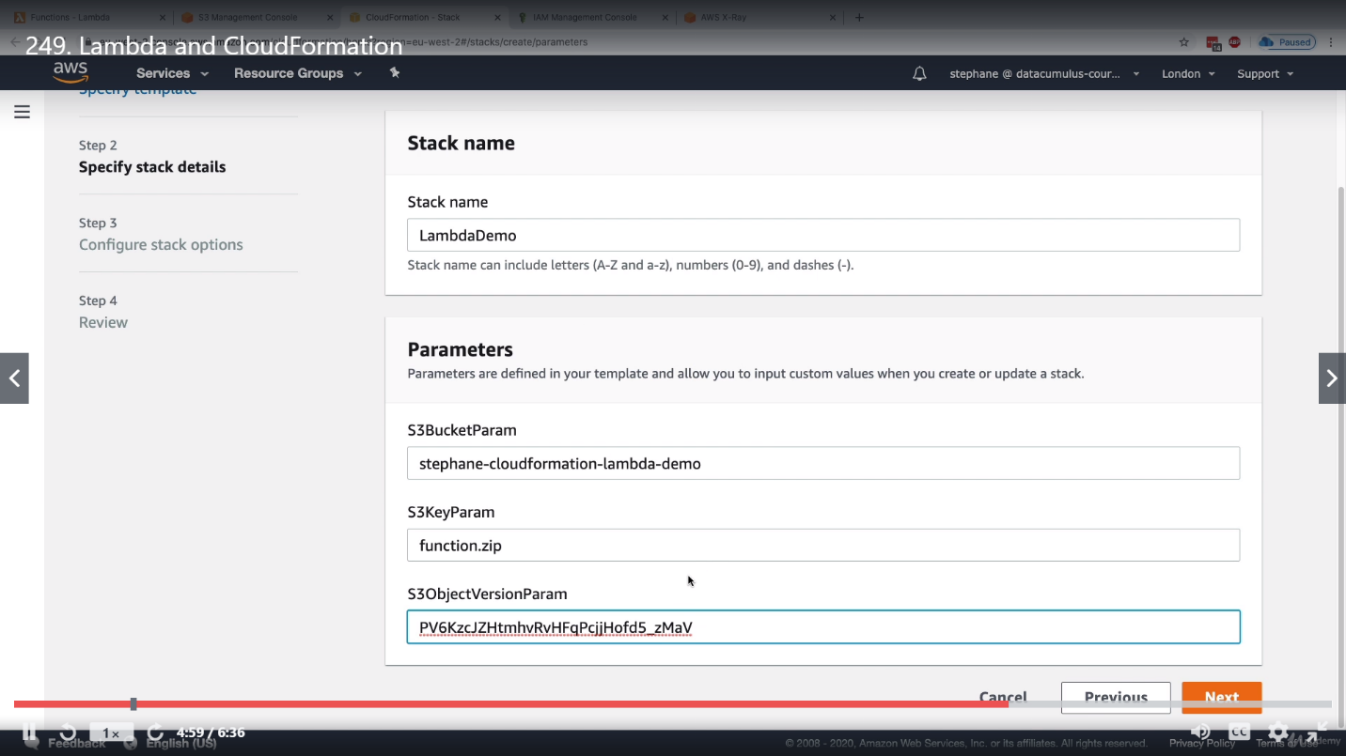

Once we have completed deployment, if we check in lambda, we would find a new lambda function been created there for it.

We can run this as usual lambda function and test it.